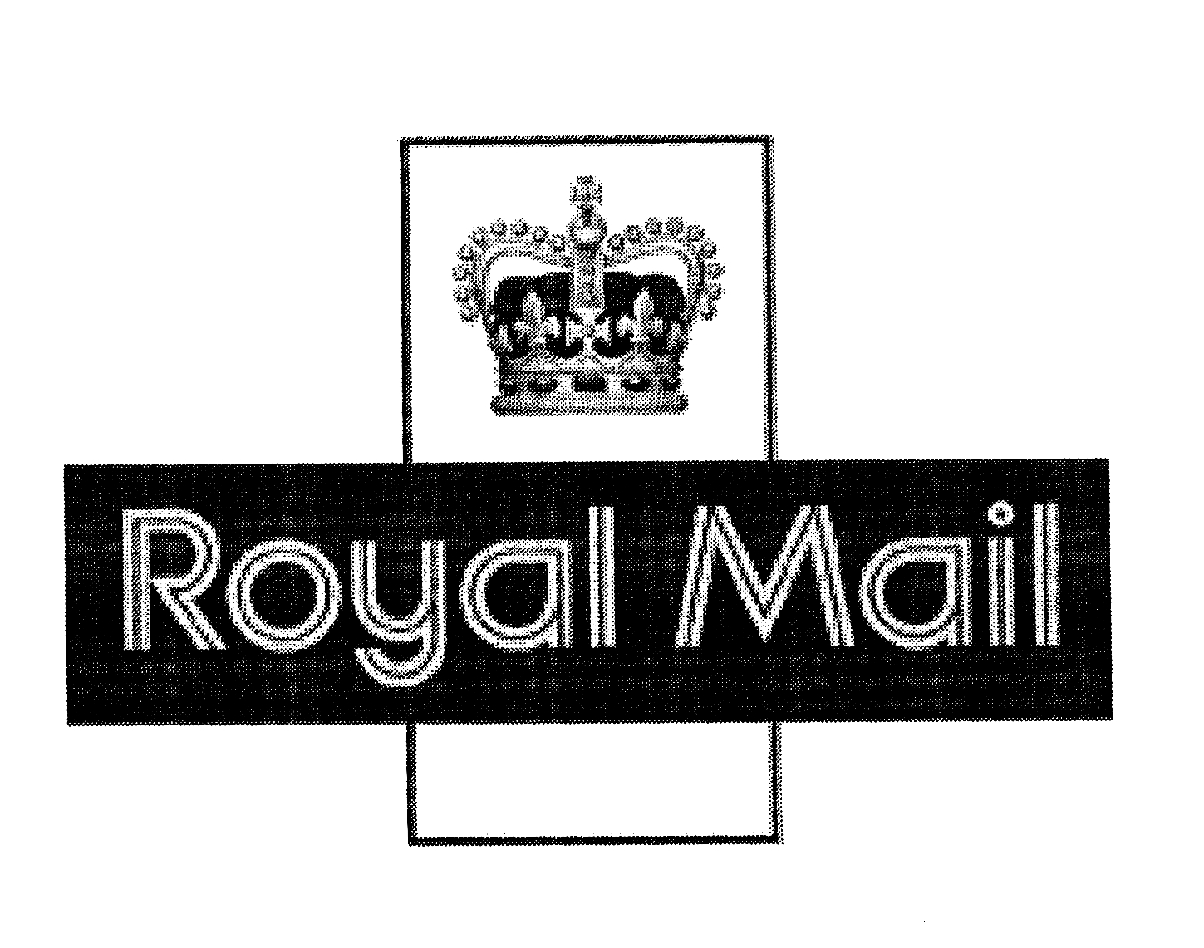 R2
Sender Details:
……………………………
……………………………
……………………………
……………………………
……………………………

Postcode: ……………

BARGAINS SOLUTIONS LIMITED
RETURNS DEPARTMENT
19 DALRYMPLE STREET
GIRVAN
SOUTH AYRSHIRE
KA26 9EU
SCOTLAND
UNITED KINGDOM

PACKETPOST RETURNS
CONTRACT No.
217670PR

Postage to be paid at destination under terms of contract

