THIS IS AN ÆNGLISH WEBSITE EXPOSING CONSERVATIVE DOGMATIC RITUAL INCANTATIONS AS THE WORK OF CORRUPT LITTLE DEVILS AFRAID OF OUR EXPOSING THE FOLLOWING TRUTHS:-
FOR ALIEN REASONS ROMAN LAW BASED GOVERNMENTS CANNOT GIVE LEGALLY SUSTAINABLE REPLIES EVEN WHEN YOU LEGALLY PROTECT YOUR RIGHT TO SUCH A REPLY UNDER ÆNGLISH COMMON LAW CONTRACT LAW FOR A LEGALLY SUSTAINABLE FEE OF £900 THOUSAND MILLION MILLION WHICH ONLY THE KNOWINGLY AND DELIBERATELY CORRUPT MUST PAY ACCORDING TO LAW.
DEFINITION OF A TERRORIST AND A CORRUPT FUNDAMENTAL EXTREMIST:-
2001 TERRORIST ACT MAKES CLEAR THAT THOSE WHO DAMAGE PROPERTY ARE TERRORISTS.
YOUR RIGHTS ARE YOUR PROPERTY AND YOUR POSSESIONS. THEREFORE, PEOPLE WHO DAMAGE YOUR RIGHTS DAMAGE YOUR PROPERTY AND MUST BE TERRORISTS BECAUSE THEY HAVE NO HONEST BELIEF IN AUTHORITY THEY CANNOT PRODUCE TO MAKE YOU DO OR SUFFER ANYTHING THEY WANT YOU TO DO OR SUFFER AT YOUR OWN EXPENSE.
THE CORRUPT MUST ALSO BE FUNDAMENTAL EXTREMIST TERRORISTS BECAUSE THEY DAMAGE YOUR RIGHT TO BE SHOWN BY THEM THE AUTHORITY THEY RELY ON FOR AFFECTING YOU AT YOUR OWN EXPENSE. THEY CANNOT SHOW WHAT DOES NOT EXIST.
FUNDAMENTAL EXTREMISTS IN GOVERNMENT, AMONGST OTHERS, COMMIT THEFT BY DECEPTION OF AUTHORITY AS WELL AS BY OTHER TERRORIST ACTS AND HAVE BEEN KNOWINGLY AND DELIBERATELY DOING SO SINCE 1911.
THE ABOVE MENTIONED ARE CORRUPT AND ARE ATTEMPT TO MAINTAIN THE BALANCE OF POWER IN FAVOUR OF THEIR OWN INTELLECTUALLY INFERIOR AND BRAIN DAMAGED PEERS IN A MANNER CONTRARY TO HUMAN RIGHTS AND ALL LAWS POSSIBLE IN A DEMOCRACY.
THIS WEBSITE PROVES THE ABOVE IS THE TRUTH BECAUSE:-
On the one hand a fundamental extremist view is correct WHEN AUTHORITY FOR IT IS SHOWN WITHIN 40 DAYS IF A PERSON WORKING FOR A STATUTORY BODY RELIES ON THAT AUTHORITY FOR THEIR HONEST BELIEF IN IT and on the other hand a fundamental extremist view is corrupt IF AN AUTHORITY DOES NOT STATE EXACTLY WHAT YOU MUST DO OR SUFFER AT YOUR OWN EXPENSE.
Therefore, fundamental extremists are people who are either; so fundamentally and extremely corrupted, that they are afraid to admit the truth because it may be socially and financially ruinous or else they are fundamentally and extremely correct.
According to law the corrupt must pay for their corruption out of their own pockets. Also, according to law everyone who is not corrupt may simply take back what they believe is their property without first seeking a court order to do so.
People who do not resort to terrorism have already recaptured the hearts and minds of other honourable people whilst putting the corrupt into disarray. A corrupted brain cannot think straight because it would be financially and socially ruinous to do so. That is how they lost their heads and why they do nothing about us. They are now so arrogant and stupid that they cannot even see that reality around them is not what they once thought it was. Reality is that the knowingly and deliberately corrupt are already in Hell working and paying for their sins whilst moaning a groaning about it and we are in Heaven sharing knowledge AT OUR OWN EXPENSE simply because we LOVE to.

Letters received show even Government ministers have failed to produce authorities

THE LAW OF CONTRACT
Rights are clearly property and possessions. Under English Common Law I may do as I please and that means I may trade my rights for as much as my imagination sees fit so long as I exercise a duty of care. I exercise my duty of care by application of the ICHOR TRUST COVENANT. Pursuant to Curry v Misa (1875)”…some right .. “being tradable property, Metropolitan Asylum District v. Hill (1881) 6 App. Cas. 193;42 Digest 7051222 Per Lord Blackburn “An Act is not in the absence of clear language to be construed as taking away property without compensation, and on those who seek to establish that the legislature intended to take away the private rights of individuals lies the burden of showing that such intention appears by express words or necessary implication.” When rights are protected by the sanctity of contract the necessary implication is that it takes IMPERATIVE WORDS OF EXPRESS MEANING BEYOND ANY DOUBT WHATSOEVER IN PRIMARY LEGISLATION to take away the rights in question. Metropolitan Asylum District v Hill (1881) 6 App. Cas. 193;42 Digest 7051222 also states, “Where the terms of a statute are not imperative, but permissive, the fair inference is that the legislature intended the discretion as to the use of the general powers thereby conferred, should be exercised in strict conformity with private rights.” My view is further supported by Carlil v. Carbolic Smoke Ball Co, Ltd., (1893) and Allen v. Gulf Oil Refining Ltd. (1981). Further, taking into consideration Blade v Higgs (1881) 10CBNS 713, the Theft Act 1968 s2b …rights being…..intangible property and an attempt to defeat the ICHOR TRUST being an attempt to defeat a trust according to the Theft Act 1968 and the COVENANT as stated below invoking the sanctity of contract. Maintaining the sanctity of contract is the supreme public interest and supreme public policy consideration because all global trade depends on maintaining the sanctity of contract and not bringing the sanctity of contract into question

I.C.H.O.R. Covenant

Q. What is this for?
A. This is a contract that asks for the authorities needed for them to have an honest belief that you must do anything at YOUR OWN EXPENCE. this includes things like:
Ringing them:(for example debt letters asking/telling you to ring them. Ask them, by what authorities you must at YOUR OWN EXPENCE ring them in consideration of the overleaf offer? If they can't produce there authorities or admit the mistake within 40 days then they owe the ICHOR Trust £900,000,000,000,000,000.00p (nine hundred thousand million million pounds sterling ) so they will be indebted to us for more money than they are worth, and it's legally binding, therefore if they ask you to pay them you can say 'pay me what you owe me, and then I will pay you what I owe you' and thay can't do much about that).
Having to obey road signs: (As it turns out they (being the government)can't show there authorities for any thing, don't you find that strange? If you don't believe us then ask them your self using this contract).
Suffering smell, sound, site pollution: (Ever wondered what gives the police the right to fly helicopters over your house? well use this contract and ask them in consideration of the over leaf offer where their authorities are for doing so, and see if you get a response, it is YOUR right to know!!!).
Q. How do I use this contract?
A. Just write a letter with your name, address, date, question and start with 'in consideration of the overleaf' and print the ICHOR Trust Covenant on the back of the letter, you must fit it on to one page and send it special delivery.

THE ICHOR TRUST COVENANT.
A NON-NEGOTIABLE UNILATERAL {( ACCEPT OR GO WITHOUT) TAKE IT OR LEAVE IT} EASILY AVOIDED STANDARD FORM OFFER OF TERMS AND CONDITIONS OF BUSINESS.
1. My MINIMUM fee for doing or suffering anything I am not legally obliged to do or suffer at my own expense is until further written notice and with immediate effect £900,000,000,000,000,000.00p (nine hundred thousand million million pounds sterling ) plus expenses plus compound interest on the whole amount due at the rate of 2% per full calendar month without prejudice to my right to sue for debt at any time without further notice and or in the alternative without prejudice to my right to sue for damages at any time without further notice and or in the alternative without prejudice to my right to exercise recaption at any time without further notice.
2. PAYMENT of the whole amount due must be into the account of ICHOR Sort Code 20 - 17 -20 Account Number 83049752. The whole amount due must be paid before noon on the fortieth (40th) day after your receipt of this offer counting the day you receive this offer unless another method of payment is agreed in writing between the offeree and the trustee of the ICHOR Trust.
3. TO ACCEPT THIS OFFER IN ANY WAY SHAPE OR FORM INCLUDING BY PERFORMANCE OF CONDUCT WITHOUT NEED OF FURTHER NOTIFICATION IS TO AGREE THAT (A) You have licensed anything and or in the alternative any person natural or corporate and or in the alternative any state of being or personality not yet discovered, even if not yet in existence, to help and assist in any way shape or form each and every offeror authorized to be an ICHOR Business Angel from now on referred to as an Angel to use whatever means are available in order for each and every Angel to remain safe and secure in the pursuit of the truth as due under this offer and or in the alternative to enter any property in your possession in order to assist recaption of any property belonging to the ICHOR Trust. (B) Any none payment of debts due when due instantly transfers title of property, goods and services and or in the alternative control of property, goods and services of the offeree up to the value of debts due by that particular offeree to the ICHOR Trust. (C) Each and every Angel taking action to assist recovery of property belonging to the ICHOR Trust is entitled to charge the minimum fee stated at paragraph 1 above and each and every Angel has an equal right to the benefits of all property vested in the ICHOR Trust. (D) Any attempt to refuse to accept this offer and or in the alternative any attempt to refuse to accede to this offer is an attempted theft because it is impossible for you to CONTINUE to have an honest belief in your authority to make such an attempt now that you know the only way to avoid accepting and or in the alternative acceding to this offer is to admit you have no IMPERATIVE words in a primary statute and or in the alternative a treaty and or in the alternative any other previous agreement which when given a strict and literal reading entitles you to claim and or in the alternative obliges you to CONTINUE to appropriate the property in question unless you show me those authorities before noon on the fortieth (40th) day after your receipt of this offer counting the day you receive this offer because you now know that is the only way you can CONTINUE to have an honest belief in your authority to appropriate the property in question. (E) The descendants of any Angel whose property is not vested in the ICHOR Trust within time after acceptance of this offer have an irrevocable right to pursue debts due to the ICHOR Trust according to this offer. (F) In plain English, you now know my terms and conditions of business and the terms and conditions of business of each and every Angel for doing or suffering anything irrespective of whatever that doing or suffering may be on each and every separate occasion that you perform an act and or in the alternative omission sufficient to form a contract and you know that the Trustee of the ICHOR Trust is only an Angel with Trustee status. (G) If you had any you have now waived all absolute and qualified privileges and immunities and I may choose the law governing the contract formed by your acceptance of this offer. (H) Trusteeship of the ICHOR Trust belongs to the founder trustee until inherited by the next of kin Angel of the founder Trustee under the obligatory condition that each and every Trustee must continue to approve the exercise of recaption and enforcement of each and every debt due irrespective of irrelevant considerations such as sex, race, colour, language, religion, political or other opinion, national or social origin, association with a national minority, property, birth or any other status of the offeree. (I) If you wish to claim you were misled into accepting this offer you must do all within your ability to convince each and every Angel that you were misled into accepting this offer. (J) Any attempt to prevent an Angel with two witnesses from pursuing evidence of any debt due to the ICHOR Trust shall be met with the appropriate necessary and unavoidable force required to pursue debts due. (K) This offer is a gateway to Angel status because if you are refused Angel status your goods and services and the goods and services of those with whom you associate must be ignored by each and every Angel because no Angel whatsoever may knowingly associate with nor buy the goods and services of known deceivers and those referred to in Revelation 22:15 as without. (L) You will comply with Malachi, 4:3. (M) The passages we refer to in the Holy Bible are those referred to in the King James version. (N) That pursuing all rights to the highest and most powerful authority in existence is in the interests of promoting the psychological and physical welfare of all beings and all their Human Rights and Fundamental Freedoms. (I will come near to you to judgment; I will be a swift witness... Malachi, 3:5), (it shall leave them neither root nor branch. Malachi, 4:1.), (And ye shall know the truth, the truth shall make you free. St. John 8:32.), (Great is truth and mighty above all things. Apocrypha 1 Esdras 4:41.), [Satyam (truthfulness). Bagavad-gïtä.] (Buddhism leads to enlightenment.), (The Accessions. These are the believers in truth; they shall have from their lord exalted grades and forgiveness and an honorable sustenance. The Holy Quran [8.4].) The founder of the ICHOR TRUST has seen technology radiating the colours of the rainbow, that enables the two swift witnesses to determine between victims and deceivers by joining different dimensions of infinity. (O) Each and every offeree and those for whom that offeree is liable may be given a state of the art lie and deception test without further notice or warning and the offeree is duty bound to notify those affected of this fact as a duty of care. (P) Deceiving subversives, amongst others, lost status and wealth and power exposed by this the Covenant preparing the way for ending time and judgment day with the almighty unarguable truth that fraud unravels everything. (Q) Everything fraudulent in reality is already unraveled assisted by the messenger of this Covenant saying "COME" to the Faithful and True we have unraveled the devils work for Angels to simply take back what is theirs without wasting time and or in the alternative wasting money and or in the alternative wasting energy seeking a favourable Court Order to do so. (R) If you think your property has been appropriated contrary to law you can go to Court and waste your time and or in the alternative your money and or in the alternative your energy but you will not waste what belongs to Angels.
4. TO AVOID ACCEPTING THIS OFFER BY PERFORMANCE simply comply, without let or hindrance, with all rights, duties and obligations owed to the offeror before noon on the fortieth (40th) day after your receipt of this offer counting the day you receive this offer.
5. TAKE NOTICE. If you fail to make payment when due the offeror reserves the right to issue a summons, claim, other process for debt and or in the alternative damages, as well as the right to exercise recaption without first obtaining a Court order to do so, without a letter before action and costs will be as between solicitor (lawyer) and client. END OF OFFER.
For a printable copy in .pdf click here (not avalible for the mo)

STATEMENT
I, Martin Mitchell, (YP 97 64 98 C), of 18 Girton Road, Haverhill, Suffolk, CB9 0JU submit the following statement and compliant:-
I am the unpaid trustee of the ICHOR Trust.
The ICHOR Trust was set up to protect the rights of all people to seek and share what they believe to be truth, knowledge and wisdom in consideration of the offer stated below.
ECHR (European Convention on Human Rights) clearly states under article 1 of protocol 1 that individuals have the right to enjoy their possessions.
I have been asked by DC 1424 Jane Stokes if I would attend Parkside Police Station to be interviewed in relation to an incident on Wednesday 4th May 2005 when a Parking Meter Attendant/Warden of Cambridge City Council Legion Parking No 15 attempted to give me a parking ticket for non payment of a parking fee even though a valid receipt for the parking fee in the form of a ticket was clearly on display on the drivers seat.
To prevent any attempt to place this issue inside any convenient box/remit without taking into consideration the massive implications of Cambridge City Council not having the statutory authority neccessary and unavoidable for it to deploy and enforce Parking meter use in the streets of its locality in the first place and therefore the incident with the Parking Attendant no 15 of Legion Parking would not have occured. I prepared this written statement.
When I showed the Parking Attendant the ticket I said whats this "Scots Mists". The Parking attendant stated it was not on the windscreen, I said, "So what the wind may have blown it off as I shut the door!!" The Parking Attendant claimed both him and his partner looked but, could not find it. I said, "What are you on commission or something? Whats your name?" and he said, "I don't have to give you my name". I replied loudly so as to put him back in his place, "I'm having you, you are a public servant and that makes me your master". I was not prepared to waist my time dealing with this individual at my own expense and as I am familiar with beurocratic nonsense and had nothing to write down his number with I decided to abate the nuisance by borrowing his lapel as I am entitled to comit a lesser crime in order to prevent a greater one. Therefore, I abated the nuisance by removing his lapel and driving away so as to avoid further confrontation. However, as soon as I could that afternoon I telephoned the Chief Executives Department of Cambridge City Council and advised them of the above and stated that if I here anymore about this I will invoke the sanctity of contract to ask by what authority any one can be made to suffer the forebearance of parking meters AT THEIR OWN EXPENSE. I have done so below.
The Authorities that are responsible for parking meters have not provided any documentation in support of their right to pollute the environment with parking meters and or in the alternative any other street clutter, such as sighns, notices, lines in the streets or indeed anything at all for that matter.
In Ocalan v Turkey 2003 (Application No. 46221/99) the Court reiterated that under the principle of equality and arms one of the features of a fair trial is that each party must be afforded a reasonable opportunity to present his case under conditions which do not place him under a disadvantage vis a vis his or her opponent. I am of the opinion that without necessary documents and/or authorities requested, it will be impossible for Cambridge City Council to prove it has a mandatory authority that states any person is obliged to suffer the forbearance of complying with their requests AT HIS OWN EXPENSE.
I am also concerned that the Police may attempt to ignore the fact that Cambridge City Council has no mandatory authority to place Parking Meters in the streets in the first place and may attempt to build a case on a void of authority because it does not wish to sue Cambridge City Council for damages and or in the aLternative prosecute Cambridge City Council for attempted theft by deception of authority because it is stealing by way of deception of authority by way of charging people for parking their vehicles when parking should be free in England because of every Englishmans Common Law Right to do as he pleases. What that means is that the Parking Meter Warden/Attendant will not be able to satisfy the honesty requirements of the Theft Act 1968 s2b for attempting to appropriate my Common Law Right to do as I please and charge his employer a fee for suffering the forebearance of being asked to pay fees for parking and or in the alternative putting the parking ticket where they want it put when both the Parking Meter Attendant/Warden and his employer have no statutory obligation or authority to expect my compliance with their illegal parking meter policy in the first place.
Therefore, the Parking Meter Warden/Attendant will be unable to prove beyond reasonable doubt that he even has the right to be perfoming what he has been deceived into thinking is an honest vocation. And if he was acting within the law the situation would never have occured and therefore it was of his own making.
Thus, the Parking Meter Warden/Attendant will not be able to comply with the Theft Act 1968 s2b because he does not have an honest belief in his authority to insist that I place the parking ticket in the windscreen and thus, he had no right to be performing that type of work in the first place and, therefore, all I did was to abate the nuisance with minimum force. Obviously I needed evidence of the incident taking place and I have it and it will only be returned after the parking attendant produces the authorities that state I must do as he claims AT MY OWN EXPENSE.
Further requirement of the provisions of Article 6(1) is the right to be heard, which includes the right to have the opportunity to present my case and know the basis of the case presented by the other side, as well as the right to a fair hearing. The European Court has held that a fair hearing includes giving reasons for the decision. (Hadjianastassion v Greece (1992) 16 E.H.R.R. 219. It also includes the concepts of equality of arms and the right against self- incrimination. I have not been provided with the AT HIS OWN EXPENSE authorities which should be as clear as they are in the Copyright Act 1920 and until I am provided with those authorities I shall continue to stand on my right to see them and each and every attempt to hinder me of my rights will be in consideration of the below stated offer.
In Watkins V Secretary of State for the home Department and others July 20th 2004, it was stated that ’even in our unwritten constitution the right of every citizen to have unimpeded access to a Court must rank as a constitutional right.’ It was also stated that ’damage is not only pecuniary but an injury imports damage, when a man is thereby hindered of his rights.’
Therefore, I submit that until Cambridge City Council produces a mandatory authority, not a permissive authority, stating that it must place parking meters in its locality and an AT HIS OWN EXPENSE authrity in express words of implicit meaning that take away my right for complying with that Act of Parliament it will not be able to prove it has an honest belief in its authority to pollute my environment with Parking Meters AT MY EXPENSE.
Further, I submit that until Cambridge City Council produces a mandatory authority stating that the parking fee receipt must be placed inside the windscreen AT HIS OWN EXPENSE all parking meters should be removed and parking should once again be free for those who have paid taxes due. Otherwise, anybody natural and or in the alternative corporate would be able to claim they can charge as much as they like for anything and set up their own little empire of fees, fines and taxation.
To attempt to ignore the fact that my rights are protected by the ICHOR Trust Covenant as stated below makes no difference to the fact that this offer is legally enforceable.
Failure to admit and or in the alternative produce, within 40 days, a strict and literal authority relied on for each question raised in consideration of the below stated offer by any individual, root or branch institution of local or central government, and any other body natural or corporate is acceptance of the following when those responsible for producing those authorities have knowledge of the following unilateral, take it or leave it, accept or go without offer and this will lead to a dominoes affect of accumulating debt requiring those deceived to sue those who mislead them right back to the source and time of the original theft by deception of authority :-
THE ICHOR TRUST COVENANT.
OTM 3:1 - 4:6, NTR 21:7 - 22:15.
A NON-NEGOTIABLE UNILATERAL {( ACCEPT OR GO WITHOUT) TAKE IT OR LEAVE IT} EASILY AVOIDED STANDARD FORM OFFER OF TERMS AND CONDITIONS OF BUSINESS.
1. My MINIMUM fee for doing or suffering anything I am not legally obliged to do or suffer at my own expense is until further written notice and with immediate effect £900,000,000,000,000,000.00p (nine hundred thousand million million pounds sterling ) plus expenses plus compound interest on the whole amount due at the rate of 2% per full calendar month without prejudice to my right to sue for debt at any time without further notice and or in the alternative without prejudice to my right to sue for damages at any time without further notice and or in the alternative without prejudice to my right to exercise recaption at any time without further notice.
2. PAYMENT of the whole amount due must be into the Woolwich plc account of ICHOR Sort Code 10 - 80 - 04 Account Number 79372187. The whole amount due must be paid before noon on the fortieth (40th) day after your receipt of this offer counting the day you receive this offer unless another method of payment is agreed in writing between the offeree and the trustee of the ICHOR Trust.
3. TO ACCEPT THIS OFFER IN ANY WAY SHAPE OR FORM INCLUDING BY PERFORMANCE OF CONDUCT WITHOUT NEED OF FURTHER NOTIFICATION IS TO AGREE THAT (A) You have licensed anything and or in the alternative any person natural or corporate and or in the alternative any state of being or personality not yet discovered, even if not yet in existence, to help and assist in any way shape or form each and every offeror authorized to be an ICHOR Business Angel from now on referred to as an Angel to use whatever means are available in order for each and every Angel to remain safe and secure in the pursuit of the truth as due under this offer and or in the alternative to enter any property in your possession in order to assist recaption of any property belonging to the ICHOR Trust. (B) Any none payment of debts due when due instantly transfers title of property, goods and services and or in the alternative control of property, goods and services of the offeree up to the value of debts due by that particular offeree to the ICHOR Trust. (C) Each and every Angel taking action to assist recovery of property belonging to the ICHOR Trust is entitled to charge the minimum fee stated at paragraph 1 above and each and every Angel has an equal right to the benefits of all property vested in the ICHOR Trust. (D) Any attempt to refuse to accept this offer and or in the alternative any attempt to refuse to accede to this offer is an attempted theft because it is impossible for you to CONTINUE to have an honest belief in your authority to make such an attempt now that you know the only way to avoid accepting and or in the alternative acceding to this offer is to admit you have no IMPERATIVE words in a primary statute and or in the alternative a treaty and or in the alternative any other previous agreement which when given a strict and literal reading entitles you to claim and or in the alternative obliges you to CONTINUE to appropriate the property in question unless you show me those authorities before noon on the fortieth (40th) day after your receipt of this offer counting the day you receive this offer because you now know that is the only way you can CONTINUE to have an honest belief in your authority to appropriate the property in question. (E) The descendants of any Angel whose property is not vested in the ICHOR Trust within time after acceptance of this offer have an irrevocable right to pursue debts due to the ICHOR Trust according to this offer. (F) In plain English, you now know my terms and conditions of business and the terms and conditions of business of each and every Angel for doing or suffering anything irrespective of whatever that doing or suffering may be on each and every separate occasion that you perform an act and or in the alternative omission sufficient to form a contract and you know that the Trustee of the ICHOR Trust is only an Angel with Trustee status. (G) If you had any you have now waived all absolute and qualified privileges and immunities and I may choose the law governing the contract formed by your acceptance of this offer. (H) Trusteeship of the ICHOR Trust belongs to the founder trustee until inherited by the next of kin Angel of the founder Trustee under the obligatory condition that each and every Trustee must continue to approve the exercise of recaption and enforcement of each and every debt due irrespective of irrelevant considerations such as sex, race, colour, language, religion, political or other opinion, national or social origin, association with a national minority, property, birth or any other status of the offeree. (I) If you wish to claim you were misled into accepting this offer you must do all within your ability to convince each and every Angel that you were misled into accepting this offer. (J) If two witnesses and one Angel produce evidence that shows you were beguiled into performing acceptance of this offer then you may become an Angel and all fees due by you shall be irrevocably waived for so long as you remain an Angel. (K) This offer is a gateway to Angel status because if you are refused Angel status your goods and services and the goods and services of those with whom you associate must be ignored by each and every Angel because no Angel whatsoever may knowingly associate with nor buy the goods and services of known deceivers and those referred to in Revelation 22:15 as without. (L) You will comply with Malachi, 4:3. (M) The passages we refer to in the Holy Bible are those referred to in the King James version. (N) Pursuing all rights to the highest and most powerful authority in existence is in the interests of promoting the psychological and physical welfare of all beings and all their Human Rights and Fundamental Freedoms. (I will come near to you to judgment; I will be a swift witness... Malachi, 3:5), (it shall leave them neither root nor branch. Malachi, 4:1.), (And ye shall know the truth, the truth shall make you free. St. John 8:32.), (Great is truth and mighty above all things. Apocrypha 1 Esdras 4:41.), [Satyam (truthfulness). Bagavad-gïtä.] (Buddhism leads to enlightenment.), (The Accessions. These are the believers in truth; they shall have from their lord exalted grades and forgiveness and an honorable sustenance. The Holy Quran [8.4].) The founder of the ICHOR TRUST has seen technology radiating the colours of the rainbow, that enables the two swift witnesses to determine between victims and deceivers by joining different dimensions of infinity. (O) Each and every offeree and those for whom that offeree is liable may be given a state of the art lie and deception test without further notice or warning and the offeree is duty bound to notify those affected of this fact as a duty of care. (P) Deceiving subversives, amongst others, lost status and wealth and power exposed by this the Covenant preparing the way for ending time and judgment day with the almighty unarguable truth that fraud unravels everything. (Q) Everything fraudulent in reality is already unraveled assisted by the messenger of this Covenant saying "COME" to the Faithful and True we have unraveled the devils work for Angels to simply take back what is theirs without wasting time and or in the alternative wasting money and or in the alternative wasting energy seeking a favourable Court Order to do so. (R) If you think your property has been appropriated contrary to law you can go to Court and waste your time and or in the alternative your money and or in the alternative your energy but you will not waste what belongs to Angels.
4. TO AVOID ACCEPTING THIS OFFER BY PERFORMANCE simply comply, without let or hindrance, with all rights, duties and obligations owed to the offeror before noon on the fortieth (40th) day after your receipt of this offer counting the day you receive this offer.
5. TAKE NOTICE. If you fail to make payment when due the offeror reserves the right to issue a summons, claim, other process for debt and or in the alternative damages, as well as the right to exercise recaption without first obtaining a Court order to do so, without a letter before action and costs will be as between solicitor (lawyer) and client. END OF OFFER.
Surely, if on the level field of the Common Law everyone has the right to do as they please and rights are property. Then anyone can charge a fee for doing or suffering anything they are not obliged in law to do or suffer AT THEIR OWN EXPENSE.
IT IS NOT LOGICAL TO PROTECT A PUBLIC SERVANT OF ANYKIND IN THE ABSENCE OF AUTHORITY AND FOR PROFESSIONALS TO CLAIM IGNORANCE OF THE LAW IS NO EXCUSE.
Every Magistrate is duty bound to accept that each and every Citizen has the right to offer to contract for continuing to go without being shown the authorities relied on by those purporting to rely on them. Each and every citizen has the right to know by what authority their property is being appropriated.
A CONSEQUENCE OF THE THEFT ACT 1968 S2(b) IS THAT THOSE WHO HAVE AN HONEST BELIEF IN AUTHORITY MUST BE ABLE TO PRODUCE IT WITHIN 40 DAYS.
REALITY IS THAT THOSE WHO COMMIT FRAUD AND CORRUPTION WILL BE INCAPABLE OF PRODUCING AUTHORITIES BECAUSE THEY DO NOT EXIST.
Also, I fail to see how an employee of a Local Authority can have an honest expectation of anyone to do or suffer anything at HIS OWN EXPENSE unless that employee can show you words in a primary Act of Parliament stating exactly what must be done and suffered because in contract law there can be no presumption of anything unless express words of implicit meaning take away an individuals right to contract for the affect in question otherwise any one would be able to charge any gullable person for anything and get away with it and if you can't prove who was trying to make you do what the guilty person could claim anything and the innocent victim would be paying for everything instead of the corrupt paying out of their own pockets as they should according to law.
It is my honest belief that no authority has existed since the 1920 Copyright Act to authorise anyone to state any Citizen must suffer anything at their own expense that is why as often as I can I apply the offer stated above.
Professionals must know the whereabouts of authorities they rely on and be able to show them to those affected. See Metropolitan Asylum District v Hill 1889.
We are all duty bound to protect the sanctity of contract upon which all global trade depends including our trade of protecting Citizen’s Rights by application of Contract Law that can only be objected to by criminals with hidden agendas, directives and policies contrary to Law who can seen how this exposes their fraud, corruption and theft by deception of authority.
Therefore, in consideration of the ICHOR Trust Covenant and your knowledge of it as laid before you, I request you honour my right to be shown the exact words in an Act of Parliament that must be relied on by those purporting to have AN HONEST BELIEF in their authority to appropriate my Common Law Right to do as I please with my property, my rights being my property.
Finally, I request that the Police insist the Parking Meter Attendant/Warden provide the evidence upon which he must rely namely; the AT HIS OWN EXPENSE authority necessary and unavoidable for him to have me or any other individual comply with his employers desires at our own expense.
I submit that my defence in this case must be heard under common law, contract law, the rules of natural justice, article 6 HRA 1998 and the Magna Carta.
Dated this 22nd day of June 2005
Full name: Martin Mitchell
Signed:………………

Home | Law of contract | The Covenant | Statements | Letters to | Letters from | Links | Contact Us |
You can contact the trustee at trustee@ichortrust.co.uk or
Aabbex© Computers WebMaster on 0870 803 1720 or click here

Back Next Statment's
Case Number 2923813
In the Magistrates Court House Queensway Mildenhall Suffolk
Chief Inspector David Barron Claimant
v
Victoria Lucy Haylock a beneficiary of the ICHOR Trust Defendant

Oral argument
I, Victoria Lucy Haylock of 6 Spartan Close Haverhill, Suffolk CB9 9QR, submit the following in support of my defence;-
I am a beneficiary of the ICHOR Trust.
I am a litigant-in-person with no background legal training.
THE ICHOR TRUST OF WHICH I AM A BENEFICIARY AT ICHORTRUST.CO.UK ALLEDGES EVIDENCE OF HOME OFFICE THEFT OF PEOPLE’S RIGHTS THAT INVOLVES THE OFFICE OF THE PRIME MINISTER AND THE LORD CHANCELLOR’S DEPARTMENT IN WHAT IS OBVIOUSLY THEFT BY DECEPTION OF AUTHORITY AND A FRAUD ON A DUTY OF CARE TO KNOW AUTHORITY RELIED ON ACCORDING TO THE THEFT ACT 1968 SECTION S2B THAT THE HOME OFFICE, AMONGST OTHER BODIES NATURAL AND CORPORATE, INCLUDING CENTRAL AND LOCAL GOVERNMENT DEPARTMENTS ARE LEGALLY OBLIGED TO SHOW THE ICHOR TRUST BUT, HAVE FAILED TO DO SO. FAILING TO PRODUCE THE AUTHORITY IN QUESTION IS IN IT’S SELF EVIDENCE OF FAUD AND CORRUPTION AIMED AT MAINTAINING THE BALANCE OF POWER IN FAVOUR OF A CRIMINAL CONSPIRACY TO FINANCIALLY EXPLOITE THE GENERAL PUBLIC FOR REASONS ALIEN TO THE ADMINISTRATION OF JUSTICE.
THEREFORE, I HEREBY PROTECT MY RIGHTS UNDER THE SUPREME PUBLIC POLICY AND THE SUPREME PUBLIC INTEREST CONSIDERATION BY INVOKING THE SANCTITY OF CONTRACT AS STATED BELOW UNDER THE HEADING THE ICHOR TRUST COVENANT.
Back Next Statment's
1 | 2 | 3 | 4 | 5 | 6 | 7 | 8 | 9 | 10 | 11 | 12 | 13 | 14 | 15 | 16 | 17 | 18 | 19 | 20 | 21 | 22 | 23 | 24 | 25 | 26 |
Back Next Statment's
The Court is comprised of all in attendance including the public who witness the process. The Court and the Crown prosecution service have been given a copy of this statement.
The Claimant is an employee of the Home Office attempting to commit theft of rights by deception of authority and by a FRAUD ON A DUTY OF CARE.
The Claimant is an employee of the Home Office and the Home Office is committing a fraud on a duty of care by failing to give legally sustainable replies to letters it is their duty to give and my right to be shown by them because I am a beneficiary of this trust. Therefore, the claimant having vicarious liability (liability that flows both up to his superiors and down from his superiors to him) pretends to exercise a duty of care when in reality he must first prove he is a FIT PERSON TO MAKE THE CLAIM HE MAKES AGAINST ME because if he cannot produce the authorities the trustee of the ICHOR Trust has made public that he wishes to see at ichortrust.co.uk then a fraud of authority will have unravelled the claimants authority to prosecute me for anything. And the Fraud they both commit is best explained as follows:-
When you are affected by something irrespective of whatever it is that is affecting you, you may request to be shown by the body affecting you the authority they need to affect you at your own expense.
Otherwise, it is obvious that for the service of being affected you may offer to contract unless sufficient authority is shown to make you suffer the affect in question at your own expense. Otherwise, you would be a slave forced to suffer an effect at your own expense and slavery is illegal. Therefore as rights are property one must have a right to contract for continuing to go without being shown what one has a right to see. That right, the right to see authority requested, is obviously tradable for as much as one may wish to trade it because it is a right and rights are property and possessions all in one.
A fraud on a duty of care and deception of authority is proven when authorities relied on cannot be shown because they do not exist. And if they do exist but, are not produced fraud on a duty of care is proven when the Government refuses to admit a mistake within 40 days and so gets into debt for £900 thousand million million by accepting our take it or leave it offer for CONTINUING to go without our right to be shown by those who rely on them the authorities they must rely on.
The Crime of a fraud on a duty of care is made even more serious when victims of fraud wait almost nine years and then ask government what they have done about it and still do not get a legally sustainable reply even though they can prove fraud beyond any doubt whatsoever with documentary evidence which victims (Hosts) have put in the public domain at www.ichortrust.co.uk.
The Lord Chancellors Department actually states in a letter that it is the duty of the Home Office to reply and obviously a legally sustainable reply must be more than a mere acknowledgement because to exercise a duty of care the Home Office must answer the questions raised other wise it will always remain liable under contract law for £900 thousand million million plus 2% compound interest
Back Next Statment's
1 | 2 | 3 | 4 | 5 | 6 | 7 | 8 | 9 | 10 | 11 | 12 | 13 | 14 | 15 | 16 | 17 | 18 | 19 | 20 | 21 | 22 | 23 | 24 | 25 | 26 |
Back Next Statment's
per month. And that would be reckless and clearly contrary to its duty of care even though it pretends (fraud) that the acknowledgement was a reply.
Therefore, you are urged to find the claimant and the crown prosecution service guilty of a fraud on a duty of care by deception of authority to prosecute me because the Home Office has unravelled its authority to govern. The Crown prosecution service would also be guilty of a fraud on a duty of care if it assists the claimant a member of what now appears to be a criminal organisation in view of the documentary evidence freely available at ichortrust.co.uk that is sufficient evidence to prove fraud on a duty of care and deception of authority for amongst other things authority is unravelled by the aforementioned fraud that unravels everything flowing from it.
Those who affect you owe you a duty of care as a right. The duty of care they must exercise is to know the authority they rely on and be able to show it to you when you request to see it. So a fraud on a duty of care resulting from a deception of authority would result in a no show of authority even when you contract to protect your right to see it for more money than exists in the whole country basically because it does not exist and cannot exist because slavery is illegal and the Home Office accepted my service of forbearance in return for my fee sent to it via the Prim Minister’s Office which also places the Prime Ministers Office into debt with us for the same amount because the PM’s Office did not exercise a duty of care to ensure we received a legally sustainable reply as the letter was originally requesting the information with our offer for continuing to go without our right was originally sent to the PM’s Office by addressing it to the Prime Minister and First Lord of the Treasury. Therefore, vicarious liability flows from the PM’s Office, the Home Office and the DCA. The DCA now having vicarious liability for the LCD.
As the Supreme public interest and public policy consideration is to maintain the sanctity of contract because global trade depends on it and not just the UK criminal ruling class terrorists and other public servants who have twisted their master servant role so much so that public servants and civil servants now think they are masters over citizens who’s rights are in reality their Sovereign Rights because everyone in a democracy has sovereign rights because each and everyone of us have an equal share in Crown Power exercisable by application of the Common Law that it is the Duty of the Judiciary by vicarious liability to the Queen to Defend as the Queen is the Defender of the Common Law and the judiciary have sworn allegiance to the Queen and the Crown having given away its power by way of the vote now means ordinary people are sovereign of their own rights.
Obviously when a power structure inverts to the point where the majority are legally in control of their own rights then those rights become inalienable tradable property possessed by the person who possess them. So if you have a right to see be shown authority by those who claim to have it by their behaviour then, we all have a right to offer to contract for continuing to go without our right to be shown the authority relied on.
The Home Office and the Office of the Prime Minister and First Lord of the Treasury are both attempting to defeat the ICHOR TRUST in a criminal manner
Back Next Statment's
1 | 2 | 3 | 4 | 5 | 6 | 7 | 8 | 9 | 10 | 11 | 12 | 13 | 14 | 15 | 16 | 17 | 18 | 19 | 20 | 21 | 22 | 23 | 24 | 25 | 26 |
Back Next Statment's
according to the Theft Act 1968 S2b by failing to show authority to the trustee that the trustee and each and every beneficiary have a right to be shown by the Home Office as Confirmed by the Lord Chancellors Department that has changed its name to the DCA (Department for Constitutional Affairs).
Even though the Trustee has written and asked the Prime Minister 21 questions that it would be a breach of a duty of care by him not to give legally sustainable replies to, no legally sustainable reply has been given in spite of extraordinary effort and the fact that we have a right to know the authority of anybody, natural or corporate, to affect us as our own expense.
It is a criminal offence to attempt to defeat a trust and yet according to the Theft Act 1968 S2b the Home Office is attempting to defeat the ICHOR Trust in contravention of my Common Law TRADABLE RIGHTS as is made crystal clear in Metropolitan Asylum District v Hill (1881) 6App Case 193 contrary to my contractual rights as made clear in Curry v Misa 1875 ….rights being tradable property because each and every one of my rights is protected by the below stated ICHOR TRUST Covenant.
The Crown Prosecution Service, or indeed any government agency or department, commits theft when they unlawfully appropriate people’s property by stealing their tradable rights.
THE CROWN PROSECUTION SERVICE commits theft by deception of authority and a FRAUD ON A DUTY OF CARE when it ignores its DUTY TO ADVISE CITIZENS OF ANYTHING THAT UNDERMINES THE CASE OF THE CLAIMANT. The case of the claimant is undermined by the fact that it is impossible to PROVE THE ACCURACY OF THE SPEED CAMERA AT THE TIME OF THE ALLEDGED SPEEDING OFFENCE AS WELL AS THE FACT THAT FRAUD UNRAVELS EVERYTHING. The fraud we refer to is the pretence of exercising a duty of care.
The Prime Minister and First Lord of the Treasury and the Home Office have enchained themselves by operating in an illegal criminal hierarchical system and will now be incapable of finding any authority sufficient to make me do or suffer anything they wish me to do or suffer AT MY OWN EXPENSE.
The last Act of Parliament that we know of to have any at your own expense authority is the Copyright Act 1911.
The web site www.ichortrust.co.uk puts in the public domain conclusive documentary evidence that central Government has failed to comply with their duty to know and show to me authority they must rely on according to Metropolitan Asylum District v Hill 1881 6App Case 193 and thus are in breach of contract according to Curry v Misa (1875) L.R.10 Exch. 153 which leaves them indebted to us for over £900 thousand million million caused by failing to give the Trustee legally sustainable authority requested by the trustee who had to request it as a duty of care to his beneficiaries and to which he remains entitled, even though it has never been shown in spite of the trustee contractiong on my and other beneficiaries behalf for CONTINUING to go without being shown the
Back Next Statment's
1 | 2 | 3 | 4 | 5 | 6 | 7 | 8 | 9 | 10 | 11 | 12 | 13 | 14 | 15 | 16 | 17 | 18 | 19 | 20 | 21 | 22 | 23 | 24 | 25 | 26 |
Back Next Statment's
authority within 40 days as is our right protected under contract as explained below.
Rights are both Property and Possessions
The ICHOR Trust Covenant is stated below and the ICHOR Trust Covenant protects my right to charge a fee of £900 thousand million million (pounds sterling) for each and every breach of my rights on an individual basis because my rights are my tradable property and, therefore, my tradable possessions there being no legally sustainable argument to the contrary as is shown at the web site www.ichortrust.co.uk by various government departments clearly failing to produce authorities they must in law rely on and, therefore, be able to produce within 40 days.
The Theft Act 1968 S2b refers to intangible property, and rights are both property and possessions being stolen from me by the Queen and/or the person who intercepted her mail because we have not received a legally sustainable reply and the judiciary have sworn allegiance to the Queen and now there is a clear conflict of interest in the judiciaries’ duty of care to defend the Common Law.
The Office of the Prime Minister and first Lord of the treasury and the Department for Constitutional Affairs have also failed to give us legally sustainable replies even though we contract and the High Court has given us obiter dictum that this is an ingenious application of contract that forces a return to the basic principles of contract.
Meaningless Summonses.
Evidence of a twist in the law is made clear by use of the phrase “Contrary to”
The nonsensical wording on Summonses and NIPs could be fundamentally due to the fact that since Sir John Popham became Lord chancellor, who incidentally is alleged to have committed highway robbery to finance his legal studies just as I claim the police are doing in a tyrannical manner by threatening to endorse my licence with points based on evidence gained in an illegal manner according to the Theft Act 1968 S2b and my Human rights, amongst other rights, by forcing me to comply under duress of losing my license and my job due to what is in reality criminal behaviour of the police and prosecution services who have no honest belief in their authority because they will not be able to produce as we have already proved at www.ichortrust.co.uk any authority for changing the Common Law meaning of contrary to into something that makes sense in a Summons.
STEALING MONEY FROM ORDINARY PEOPLE TO PAY THE WAGES OF THE CORRUPT.
Sir John Popham, did knowingly and deliberately twist the law in a fundamentally extreme and corrupt way so as to gain favour of the establishment and capitalists of the day namely the Elizabethan Crown. Sir John
Back Next Statment's
1 | 2 | 3 | 4 | 5 | 6 | 7 | 8 | 9 | 10 | 11 | 12 | 13 | 14 | 15 | 16 | 17 | 18 | 19 | 20 | 21 | 22 | 23 | 24 | 25
Back Next Statment's
Popham’s conflict of interest between Crown and Citizen’s rights appears to have continued until the present day. Evidence of hierarchical theft is an inability to produce strict and literal authority for acts and omissions in question and a major conflict of interest in a democracy is that judges have sworn allegiance to the Queen, amongst other things, which is clearly contrary to ordinary peoples rights because judges should be swearing to uphold the Common Law Rights of Citizens instead of attempting to maintain the balance of power in favour of a criminal ruling class terrorist mentality attempting to steal and thus damaging ordinary peoples’ rights contrary to law.
Due to Sir John Pophams obvious conflict of interest with his Common Law duties and obligations in that he wished to retain his head that Elizabethan Crowns were not averse to decapitating. Therefore, he ensured he kept his head by being of financial value to those Crown heads even though it was contrary to law for him to twist the law in favour of them.
All Lord Chancellors are duty bound like the rest of us to exercise a duty of care by knowing the authorities they must in law rely on when but which in reality do not exist and are likely to show a crystal clear and massive FRAUD ON A DUTY OF CARE that enables establishment criminals to siphon money out of the public purse into their hierarchical systems in an attempt to maintain their doomed financial status.
We see no reason why we should not untangle the mess left behind by Sir John Popham and every Lord Chancellor since him by invoking the sanctity of contract and contracting with the Queen, the Prime Ministers’ Office, the Home Office, and the Department for Constitutional Affairs for CONTINUING TO GO WITHOUT OR RIGHT TO BE SHOWN AUTHORITY THEY MUST RELY ON.
In this country we have all been living in a democracy now for over 4 generations and that is more than enough time for the damage Sir John Popham caused to have been repaired. It is clearly a criminal offence to continue to operate the law in an hierarchical manner with judges swearing allegiance to the Queen contrary to people’s democratically gained sovereign rights and Human Rights. Therefore, Judges should be swearing to uphold everyone’s’ Sovereign and Human Rights which is the opposite of their present oath of allegiance to the Queen. Public servants are servants of the public and the word civil in Civil servants comes from the Latin civus meaning citizen (public). And they are both the servants of the people who are therefore, their masters. Thus, the Establishment are so confused they think they are more important than us when in reality they are our servants not our masters.
Rights are property and possessions worth much more than capital when anyone may charge more than any capitalist hierarchical terrorist mentality could possibly afford to pay for any breach of any right and all rights are sovereign rights.
The Department for Constitutional affairs now carries the duties and obligations of the Lord Chancellors Department and it should be unravelling all knowingly and deliberate fundamentally and extremely corrupt fraud on a duty of care that is proven by the Law Society, Crown Prosecution Service, the Courts,
Back Next Statment's
1 | 2 | 3 | 4 | 5 | 6 | 7 | 8 | 9 | 10 | 11 | 12 | 13 | 14 | 15 | 16 | 17 | 18 | 19 | 20 | 21 | 22 | 23 | 24 | 25 | 26 |
Back Next Statment's
the Police, the Department for Constitutional Affairs, the Queen who is also the defender of the Common Law, the Prime Minister’s Office and the Lord Chancellors Department, amongst others, with vicarious liability and or in the alternative others reliant on their services being totally incapable of producing authorities they must in law rely on to assert that anyone must suffer a breach of their rights at their own expense.
Contracts of adhesion (they are stuck with it) on Queen, Prime Minister, Home Office and many others.
ICHOR TRUST COPYRIGHT MATERIAL AVAILABLE FOR EVERYONE WHO IS HONOURABLE ENOUGH TO WISH TO PROTECT THEIR RIGHTS UNDER CONTRACT LAW.
At www.ichortrust.co.uk our trustee Martin Mitchell publishes letters to him as well as internal letters between government departments that are evidence that those departments have failed to produce authorities they must in law rely on and, therefore, must be able to show us within 40 days and must do so to avoid liability under the ICHOR Trust Covenant.
CORRUPTION LEADS TO POLLUTION ENCIRCALLING THE PLANET CONTRARY TO A DUTY OF CARE THAT MUST BE EXERCISED. THUS POLLUTION IS EVIDENCE OF A FRAUD ON A DUTY OF CARE.
Corruption leads to pollution of mind body and Earth.
One letter from the DTI actually states to us states that our letter to the Prime Minister and I quote, “raises issues across a number of Government policy areas”. That was way back in 1998 and yet the corruption continues as though it is an inevitable part of progress when in reality corruption is evidence of deception and deception is evidence of a fraud on a duty of care that leaves a massive debt caused by the pollution of mind, body and planet. This corruption enabled environmental pollution leaves a massive debt that is, was and shall always be inherited by those who benefit from the corruption whilst those of us who are bringing the benefits of corruption to an end will inherit the Earth and the children of the corrupt will be working off their debt unless they join us by admitting the truth and so passing the buck.
The above mentioned DTI letter is evidence that hidden agendas, directives and policies contrary to law continue to this day and further evidence of both Central and Local Government fraud on a duty of care and corruption is proven when they find it impossible to comply with the ruling in the case of Metropolitan Asylum District v Hill 1881 6App Cas.193 that makes clear that those who rely on an authority must show it to people that they wish to have comply with it, which is obvious because if I am affected by something then those relying on authority to affect me AT MY OWN EXPENSE MUST show the authority to me AT THEIR OWN EXPENSE because I have a right to see the authority.
Back Next Statment's
1 | 2 | 3 | 4 | 5 | 6 | 7 | 8 | 9 | 10 | 11 | 12 | 13 | 14 | 15 | 16 | 17 | 18 | 19 | 20 | 21 | 22 | 23
| 24 | 25 | 26 |
Back Next Statment's
Obviously, I cannot be forced at my own expense to visit other peoples’ areas to view something I have a right to see and, therefore, authorities must be sent free of charge. As I have a Common Law Right to see authority that takes away my Common Law right then I may also charge as much as I wish for going without being shown that authority to make me suffer the loss of my right AT MY OWN EXPENSE AND THE COURTS ARE NOT ALLOWED TO LOOK IN HOW MUCH I CHARGE AS A FEE for going without being shown authorities I have a right to be shown.
If for any reason whatsoever an AT YOUR OWN EXPENSE AUTHORITY is not shown within a reasonable time and the 40 days we allow is much more than reasonable. Then, if those who rely on an authority for an honest belief but can’t remember it or find it or admit the truth is that it does not exists within 40 days it is clearly obvious they cannot have an honest belief in its existence and are thus criminals committing theft by deception of authority and may even be terrorists because they are damaging other peoples property, rights being property and possessions.
An inability by Central Government to show legally sustainable authority, upon which Government departments and agencies MUST rely, is also evidence of fraud on a duty of care and corruption by Central Government top dogs.
Honest belief in authority
For Central Government, the Queen, amongst others, to be able to legally sustain that they have an honest belief in an authority that complies with the law according to the Theft Act 1968 S2b that authorises them to appropriate our right to legally sustainable replies AT MY OWN EXPENSE they must be able to produce it. The Queen is not exercising her Common Law duty of care that is to defend the Common Law and the Judiciary too often fail to do so without authority.
Failure to produce authorities is all the cause and grounds we need to exercise our duty of care to carry out further investigation to protect our beneficiaries from CONTINUING to suffer fraud and corruption of authority designed to steal citizens rights in order to keep wealth flowing towards the criminal ruling class terrorists mentalities.
TERRORIST GROUPS OPERATING WITHING GOVERNMENT
Governments inability to produce authority it must rely on to have an honest belief in that authority is evidence of CORRUPTION AND THEFT BY DECEPTION OF AUTHORITY that is also A FRAUD ON A DUTY OF CARE amongst other illegal criminal behaviour THAT MAY PROVE TO BE THE ACTIONS OF TERRORIST GROUPS OPERATING WITHING GOVERNMENT WHOS AIM IS TO SERIOUSLY DAMAGE ORDINARY PEOPLES RIGHTS RIGHTS BEING PROPERTY AND THE POSSESIONS OF THOSE TO WHOM THEY BELONG because rights are the sovereign property of the people to whom they belong in our Common Law Democracy.
Back Next Statment's
1 | 2 | 3 | 4 | 5 | 6 | 7 | 8 | 9 | 10 | 11 | 12 | 13 | 14 | 15 | 16 | 17 | 18 | 19 | 20 | 21 | 22 | 23 | 24 | 25 | 26 |
Back Next Statment's
Local and central government employees are unlawfully appropriating ordinary people’s Common Law rights contrary to law in order for public servants to maintain the balance of power in favour of state institutions and organizations contrary to ordinary people’s Common Law tradable rights according to Curry v Misa (1875) L.R.10 Exch. 153 because a Common Law Right is tradable property and therefore the right in question may only be subject to a mandatory statute given full and proper royal Assent that states exactly what a person must do and or in the alternative suffer at their own expense.
In reality to be invited to attend court for an alledged speeding offence when the Police have not given me any evidence sufficient to demonstrate to this court that their camera is reliable and that they have seen the MANDATORY Authority the Highways Authority need to rely on for authority to place camera recording equipment in the streets and that we must suffer the forbearance of such camera recording equipment AT OUR OWN EXPNSE.
Criminal ruling class terrorists rely on tyranny and putting people under duress to make them comply with; their illegal ruling class hidden agenda and other criminal activities that have infiltrated government institutions and organisations world wide and they knowingly and deliberately ignore citizens’ contractual rights because to avoid breaching peoples’ rights even though it causes serious damages to property forces the burden of cost down to the less well educated and that is terrorism and theft and fraud on a duty of care and fraud unravels everything flowing from it.
By the establishment attempting to hide for at least 4 generations the fact that rights are tradable it now only takes one clearly written letter to expose them as corrupt because they then all close doors and refuse to answer letters which is just what we want in order for them to perform acceptance of our offer.
Criminals that have infiltrated government ensure citizens are given an inadequate education contrary to Human Rights and Misa v Curry 1875 by failing to ensure ordinary children are taught the fundamental and extremely important basic principles of contract and law at school whilst the rich get richer stealing more and more property (rights) from ordinary honourable people who are simply victims of criminals attempting to maintain corrupted old and build new corrupted institutions and organisations that enable them to continue to siphon off more money from the public purse at the expense of honourable taxpayers contrary to Law.
The ICHOR Trust covenant is legally binding on each and every body natural and or in the alternative corporate that has knowledge of the ICHOR Trust covenant irrespective of any other consideration whatsoever. Those who have knowledge of the ICHOR Trust covenant include, amongst others, the Law Society, the Office of the Prime Minister, the Queen and the Department for Constitutional Affairs and others. Therefore, all crown servants and those exercising the duties and obligations of the crown have vicarious liability under the ICHOR Trust covenant that is legally binding on them and which only terrorists and other criminal mentalities would attempt to knowingly and deliberately breach and yet the Office of the Prime Minister and first lord of the treasury is in breach of our offer to it.
Back Next Statment's
1 | 2 | 3 | 4 | 5 | 6 | 7 | 8 | 9 | 10 | 11 | 12 | 13 | 14 | 15 | 16 | 17 | 18 | 19 | 20 | 21 | 22 | 23 | 24 | 25 | 26 |
Back Next Statment's
HOW PUBLIC AND CIVIL SERVANTS BRING THEIR OFFICES INTO DISREPUTE.
Only a corrupted capitalist terrorist attempting to damage proprietary rights could disagree that a terrorist is one who either threatens to seriously damage property or actually seriously damages property.
Those same corrupted members of society might also try to disagree with the fact that Common Law rights are obviously the property and possessions of the person to whom they belong unless an Act of Parliament given full and proper Royal Assent states in mandatory words which when given a strict and literal meaning state exactly what must be done and or in the alternative must be suffered AT MY OWN EXPENSE.
It is obviously serious damage to property and disreputable to deny a person their tradable rights because rights are the property and possessions of those to whom they belong and those who attempt to steal rights by deception of authority are now finding they are being criminalised and quite rightly too because they are criminals committing theft and terrorism by fraud and or in the alternative deception of authority.
There is also the question of a fraud on a duty of care being practised against ordinary people contrary to their tradable rights.
We exercise a duty of care by giving everyone we consider to be an honourable truth seeker and sharer automatic beneficiary status of the ICHOR Trust even without their knowledge. The deployment of deception technology linked to Artificial Intelligence will prove beyond reasonable doubt that we are not attempting to deceive anyone whilst corrupt and selfish people may attempt to claim that deception technology does not work because they are too brain damaged to know when they have been beaten, medical science confirms telling lies causes brain damage, and so the corrupt members of national and international institutions and organisations of government are either incapable of thinking straight or are knowingly and deliberately corrupt.
The police can not have an honest belief in their authority to prosecute an individual for exceeding speed limits when they know from experience that they cannot prove the accuracy of the calibration of their equipment on each and every occasion that an individual is purported to have exceeded a legally enforceable speed limit and will find it impossible to show they have an honest belief that the relevant Highways authority have an obligatory authority ordering the deployment of safety/speed/traffic cameras of sufficient authority to make me suffer them at my own expense.
Subordinate legislation, rules, regulations and orders do not override the sanctity of contract only Primary Legislation in the form of an Enabling Act of Parliament given full and proper royal assent with financial provision for its execution that clearly states who must suffer what AT THEIR OWN EXPENSE is sufficient to take away private tradable rights and no one has shown any such authority even though it has been asked for via the Prime Ministers Office and
Back Next Statment's
1 | 2 | 3 | 4 | 5 | 6 | 7 | 8 | 9 | 10 | 11 | 12 | 13 | 14 | 15 | 16 | 17 | 18 | 19 | 20 | 21 | 22 | 23 | 24 | 25 | 26 |
Back Next Statment's
the Department for Constitutional Affairs which was then called the Lord Chancellors department and the evidence is on display at www.ichortrust.co.uk and it is a criminal offence to attempt to defeat a trust.
No one has ever shown any authority that obliges me and or in the alternative any other beneficiary of the ICHOR Trust, to do or suffer anything AT THEIR OWN EXPENSE in any Act of Parliament other than the Copyright Act 1911. Therefore, I have a Common Law right to use the ICHOR Trust covenant as published at www.ichortrust.co.uk and copied below to expose what is in reality theft by deception of authority and or in the alternative terrorism and or in the alternative a fraud on a duty of care as practised by Law Society members, the Crown and Crown servants, amongst others, who have all inverted their democratic duty of care contrary to all Law by operating the law in an illegal and hypocritical way that gives capitalists and the class system priority over ordinary peoples’ Common Law rights. We believe hypocrisy is the source of all terrorism on both sides of the war on terror and that western societies are controlled by terrorists attempting to maintain the balance of power in favour of a criminal ruling class and capitalist mentality contrary to law as is exposed by the ICHOR Trust at www.ichortrust.co.uk
ALLEGATION OF EXCEEDING PERMITTED SPEED LIMIT.
The Police have not given me any evidence sufficient to demonstrate to this court that their camera is reliable. The reliability of such a speed camera needs to be proven by the police because it is the duty of those who claim the law has been broken to prove their argument beyond reasonable doubt.
The Police have not given me any evidence sufficient to demonstrate to this court that the highways authority has an honest belief in its authority to deploy speed cameras and or in the alternative any other street clutter such as parking meters amongst other things whilst making ordinary people suffer the forbearance of the pollution of our environment with these capitol and revenue raising forms of environmental street clutter at our own expense.
There is no evidence to show that the speed they allege can be accurately measured given no indication of the reliability of the speed measuring device.
Manchester United player, Dwight Yorke, was cleared of speeding on a technicality. The sidelined striker was accused of driving his Mercedes CL500 at 85mph in a 70mph zone. Police measured his speed on the A34 in Wilmslow, Cheshire, last March with a hand held laser gun. His solicitor Nick Freeman told Macclesfield Magistrates that although the speed gun was Home Office approved, there was no evidence police had followed some conditions of approval.
'Proscribed device'
Mr. Freeman said: "I argued that whilst the Crown proved the device had Home Office approval, there was no evidence that the conditions of approval had been complied with.
"It is a technicality of the law. A measurement made by a proscribed device is not admissible unless any conditions subject to which approval is given are
Back Next Statment's
1 | 2 | 3 | 4 | 5 | 6 | 7 | 8 | 9 | 10 | 11 | 12 | 13 | 14 | 15 | 16 | 17 | 18 | 19 | 20 | 21 | 22 | 23 | 24 | 25 | 26 |
Back Next Statment's
followed.”((Where they have failed to meet the standards prescribed by the manufacturers (not necessarily APCO as those recommendations are good practice only it would be relatively easy under cross-examination, to cast doubt on the prosecution evidence thereby forcing the bench to return a not guilty verdict)).
Mr. Freeman did not specify the exact conditions which the police were unable to prove they followed.
Mr. Yorke was not present at court for the verdict but Mr. Freeman said: "I am sure he will be very pleased."
The onus is on the police proving that the speed gun was officially authorized for use. He asked them to produce a certificate for the device outlining the Home Office's conditions of use. I may not be rich or famous but the law is for all to obey.
Police have filed copious documents but have not provided the Court with the Home Secretaries conditions for approval, for how the camera must be used.
The relevant Highways authority will not be able to produce any mandatory authority sufficient to put into abeyance my private right to charge a fee for suffering the environmental pollution of safety/traffic/speed cameras whenever I see one. In fact there may be no mandatory authority on Highways authorities to provide anything not even parking meters. A lack of mandatory authority with a lack of a financial provision for enforcement leaves local authorities liable to prosecution for theft, amongst others things, by deception of authority.
ECHR (European Convention on Human Rights) clearly states under article 1 of protocol 1 that individuals have the right to enjoy their possessions. I have been charged with a driving offence which carries a summary penalty. The Police and or in the alternative other Authorities that are responsible have not provided any documentation in support of their arguments that:-
1). I allegedly exceeded the speed limit.
2). That their recording camera was maintained as per requirement and the police and/ or Authorities that are responsible have failed to provide the Court with the Home Secretaries conditions for approval, for how the camera must be used.
3). they did not supply any test certificates.
4). Police did not offer any guarantees sufficient to exclude any legitimate doubt in this matter and acted with lack of independence or impartiality.
5). The Crown Prosecution Service failed in their duty to advise me of anything that undermines the Crowns’ case against me by failing to advise me of what is judicially noticed above under my heading 'Proscribed device'.
Back Next Statment's
1 | 2 | 3 | 4 | 5 | 6 | 7 | 8 | 9 | 10 | 11 | 12 | 13 | 14 | 15 | 16 | 17 | 18 | 19 | 20 | 21 | 22 | 23 | 24 | 25 | 26 |
Back Next Statment's
6). The Crown Prosecution Service has further failed in their duty to advise me of anything that undermines the Crowns’ case against me by failing to advise me that there is no legally sustainable extrinsic authority for changing the Common Law meaning of contrary to into something that would make sense in a summons because Contrary to does not mean the same thing under Common Law English as According to. This is explained under my heading “House keeping Tort” below.
7). The Police have not provided me with any authority that makes it mandatory for any local authority to deploy safety/speed/traffic cameras.
8). The Police have not provided me we with any authority that makes it mandatory for me to supply the details they requested on their Notice of Intended Prosecution AT MY OWN EXPENSE contrary to laws on slavery and thus contrary to my offer of terms and conditions of business as notified to the Prime Minister and First Lord of the treasury’s Office and the Queen in order to tie in each and every head of state and the subordinate offices, institutions and organisations that they head under the law of vicarious liability.
9). The Home Office has failed to give a legally sustainable reply to the ICHOR Trust in breach of contract law and as it is a criminal offence to attempt to defeat a trust, therefore, there is no legally sustainable reason as to why I should comply with the requests of the police who have vicarious liability for the duties and obligations of the Home Office that is indebted to the ICHOR Trust and me and all other beneficiaries of the ICHOR Trust vicariously for my fee due according to my tradable rights because I have not received a legally sustainable reply to letters I have contracted around to protect my right to a legally sustainable reply. See www.ichortrust.co.uk for evidence of what I claim is the Home Office and other government and members of parliament attempting theft by deception of authority by failing to give the trustee legally sustainable replies to letters sent to and received and acknowledged by them.
10). The Police have not provided me with any evidence of their authority for changing the Common Law meaning of contrary to into something that would make sense in a Summons. By that I mean if I am summonsed for having done something contrary to that which follows contrary to and what follows contrary to is illegal then strictly speaking the summons is an inverted nonsense because if I have done something allegedly illegal it would be illegal according to whatever follows according to and not contrary to what follows contrary to.
11). The Police do not have an honest belief that the local Highways authority has a mandatory obligation to deploy speed/safety/traffic
Back Next Statment's
1 | 2 | 3 | 4 | 5 | 6 | 7 | 8 | 9 | 10 | 11 | 12 | 13 | 14 | 15 | 16 | 17 | 18 | 19 | 20 | 21 | 22 | 23 | 24 | 25 | 26 |
Back Next Statment's
cameras or for that matter any other street clutter and are misleading the Court into thinking that people MUST SUFFER THE POLLUTION OF THEIR ENVIRONMENT WITH THIS TYPE OF STREET CLUTTER AT THEIR OWN EXPENSE. Street clutter is deployed for reasons only known to those who purportedly authorise their deployment. The deployment of unauthorised street clutter is visible pollution and evidence of a money making scam by way of criminal activity by local authorities that are in reality void of any authority sufficient to take away a private persons right to contract for suffering street clutter pollution and the police assisted by the crown prosecution service mislead the Courts into ordering fines when in reality neither the police, the crown prosecution service nor the Courts can comply with the Theft Act 1968 S2b because the Police will only find the local authority has permissive authority and permissive authority does not take away a private persons contractual rights.
I am being accused of speeding, but the Police did not calibrate the device properly. Failure to follow APCO or manufacturers rules on calibration/re-calibration will not make a prosecution invalid. What it will do however is give the defendant excellent grounds for pleading not guilty and thereby forcing the police to prove their case beyond reasonable doubt.
On the question of right to legal aid or representation the court pointed out that the key principle governing Article 6 is fairness and the Court concluded that the parents in the case of P, C & S (Application no. 56547/00) did not have fair and effective access to Court as required by Article 6§1.
In Ocalan v Turkey 2003 (Application No. 46221/99) the Court reiterated that under the principle of equality and arms one of the features of a fair trial is that each party must be afforded a reasonable opportunity to present his case under conditions which do not place him under a disadvantage vis a vis his or her opponent. I am of the opinion that without necessary documents and/or MANDATORY NOT PERMISSIVE authorities requested, I will not get a fair trial.
Further, I am also of the opinion that I will not get a fair trial because I am a beneficiary of the ICHOR Trust to which the Queen and the Office of the Prime Minister as well as the Home Office and the Department for Constitutional Affairs, amongst others, with vicarious liability due to their knowledge of the ICHOR Trust Covenant as published at www.ichortrust.co.uk and the aforementioned therefore owing to beneficiaries of the ICHOR Trust more money than their assets are worth and taking into consideration that judges swear allegiance to the Queen and all the unavoidable conflict of interest issues raised because in reality citizens now have sovereign rights because we all have a right to vote.
Further requirement of the provisions of Article 6(1) is the right to be heard, which includes the right to have the opportunity to present my case and know the basis of the case presented by the other side, as well as the right to
Back Next Statment's
1 | 2 | 3 | 4 | 5 | 6 | 7 | 8 | 9 | 10 | 11 | 12 | 13 | 14 | 15 | 16 | 17 | 18 | 19 | 20 | 21 | 22 | 23 | 24 | 25 | 26 |
Back Next Statment's
a fair hearing. The European Court has held that a fair hearing includes giving reasons for the decision. (Hadjianastassion v Greece (1992) 16 E.H.R.R. 219. It also includes the concepts of equality of arms and the right against self- incrimination.
I would remind this Court of the fact that the rights of those invited to Court are constitutional. In Watkins V Secretary of State for the home Department and others July 20th 2004, it was stated that ‘even in our unwritten constitution the right of every citizen to have unimpeded access to a Court must rank as a constitutional right.’ It was also stated that ‘damage is not only pecuniary but an injury imports damage, when a man is thereby hindered of his rights.’
ECHR (European Convention on Human Rights) clearly states under article 1 of protocol 1 that individuals have the right to enjoy their possessions. I have been charged with a driving offence which carries a summary penalty. The Police and/ or Authorities that are responsible have not provided any documentation in support of their arguments that is i.e. contrary to means the same thing under Common Law English as According to and the police and/ or Authorities that are responsible have failed to provide the Court with the Home Secretaries conditions for approval, for how the camera must be used. The Police and/ or Authorities that are responsible have not provided any documentation to sustain a claim that my Common Law rights are not my property and not my possessions and that I do not have a right to enjoy my possessions by charging £900 thousand million million for unauthorised and therefore, illegal appropriation of my rights that are my property and my possessions so long as I exercise a Common Law duty of care.
In the theatre people who put money into a show are called angels and we call angels people who help us exercise our rights by becoming beneficiaries of our trust and thereby putting their trust in the ICHOR Trust. We exercise our Common Law duty of care that is a right possessed by all honourable people we affect by allowing them to become a beneficiary of our trust subject to their acceptance by performance of the ICHOR Trust Covenant. On the other hand those who breach our offer also accept our offer unfortunately they become liable to the hosts of their abuse,
THE ICHOR TRUST COVENANT
The ICHOR Trust was set up by the trustee to protect rights that are also property and the possessions of the person to whom they belong so that all honourable people capable of passing our state of the Art deception tests may offer to trade their rights in consideration of the offer stated below as ICHOR BUSINESS ANGELS and so avoid continuing to suffer at their own expense any breach of any right by any body natural and or in the alternative corporate unless an Act of Parliament given full and proper Royal assent states exactly what must be done and or in the alternative suffered AT HIS OWN EXPENSE. Rights are tradable and therefore, have a greater value than capital because any one may offer to charge much more than any capitalist could afford to pay for any affect on any individual’s proprietary rights which are also therefore,
Back Next Statment's
1 | 2 | 3 | 4 | 5 | 6 | 7 | 8 | 9 | 10 | 11 | 12 | 13 | 14 | 15 | 16 | 17 | 18 | 19 | 20 | 21 | 22 | 23 | 24 | 25 | 26 |
Back Next Statment's
tradable property and tradable possessions. The implications for corrupt capitalists is clear and of no concern to me.
No at his own expense authority has been found by the ICHOR Trust in any Act of Parliament other than the Copyright Act 1911. When the trustee or beneficiaries of the ICHOR Trust ask authorities to show where it states any body must do or suffer anything AT THEIR OWN EXPENSE no body natural and or in the alternative corporate have ever complied with their duty and obligation to show any AT HIS OWN EXPENSE authority in any primary statute and have to date failed to admit the truth within the generous 40 day time scale beneficiaries of the ICHOR Trust allow to avoid liability for our offer. None the less, only a primary statutory authority in the form of an Act of Parliament which when given a strict and literal reading and full and proper Royal Assent with financial provision has authority to take away any individuals right to offer to contract in consideration of the ICHOR Trust Covenant as stated below for doing or suffering anything any body may not wish to do or suffer AT THEIR OWN EXPENSE. There are now questions raised by the world famous archaeologist Tony Robinson over the legitimacy of our purportedly Royal Family and, therefore, Royal Assent for an Act of Parliament. I believe exercising a duty of care in this case means the Queen should have a genetic test to prove she is of Royal blood which would not in any event make any difference to the tradable rights of ICHOR Trust beneficiaries.
FUNDAMENTAL AND EXTREME TERRORIST CRIMINAL HYPOCRISY
If the Law Society, the Crown Prosecution Service, the Courts, the Police, the Department for Constitutional Affairs and others now with vicarious liability for the ICHOR trust covenant are incapable of producing authorities they must in law rely on then, continuing to prosecute people for alleged speeding offences must be a knowing and deliberate theft by deception of authority and may then also be a fraud on a duty of care which unravels everything flowing from the fraud because fraud unravels everything.
In plain English fines for allegedly exceeding speed limits must be refunded together with compensation for damages because even people who plead guilty can only be doing so because they are in terrorum (in terror) and thus, under the duress of being fined even more by people damaging their rights, rights being property and possessions. And due to the class system people most likely to be beguiled by the corrupt are the least well educated and least well motivated.
According to terrorist legislation those who threaten to seriously damage property or who actually damage property are terrorists. See the Terrorist Act 2001 bearing in mind that rights are property and, therefore, rights are the possessions of those to whom the rights belong then Human Rights Article 1 protocol 1 is also an effective means of appeal in my this case, if it comes to it.
To attempt to ignore the fact that my Human Rights are my property and possessions when protected by the ICHOR Trust Covenant as stated below and published at www.ichortrust.co.uk makes no difference to the fact that the ICHOR Trust Covenant is legally enforceable by necessary and unavoidable force.
Back Next Statment's
1 | 2 | 3 | 4 | 5 | 6 | 7 | 8 | 9 | 10 | 11 | 12 | 13 | 14 | 15 | 16 | 17 | 18 | 19 | 20 | 21 | 22 | 23 | 24 | 25 | 26 |
Back Next Statment's
THE ICHOR TRUST COVENANT.
OTM 3:1 - 4:6, NTR 21:7 - 22:15.
A NON-NEGOTIABLE UNILATERAL {( ACCEPT OR GO WITHOUT) TAKE IT OR LEAVE IT} EASILY AVOIDED STANDARD FORM OFFER OF TERMS AND CONDITIONS OF BUSINESS.
1. My MINIMUM fee for doing or suffering anything I am not legally obliged to do or suffer at my own expense is until further written notice and with immediate effect £900,000,000,000,000,000.00p (nine hundred thousand million million pounds sterling ) plus expenses plus compound interest on the whole amount due at the rate of 2% per full calendar month without prejudice to my right to sue for debt at any time without further notice and or in the alternative without prejudice to my right to sue for damages at any time without further notice and or in the alternative without prejudice to my right to exercise recaption at any time without further notice.
2. PAYMENT of the whole amount due must be into the Woolwich plc account of ICHOR Sort Code 10 - 80 - 04 Account Number 79372187. The whole amount due must be paid before noon on the fortieth (40th) day after your receipt of this offer counting the day you receive this offer unless another method of payment is agreed in writing between the offeree and the trustee of the ICHOR Trust.
3. TO ACCEPT THIS OFFER IN ANY WAY SHAPE OR FORM INCLUDING BY PERFORMANCE OF CONDUCT WITHOUT NEED OF FURTHER NOTIFICATION IS TO AGREE THAT (A) You have licensed anything and or in the alternative any person natural or corporate and or in the alternative any state of being or personality not yet discovered, even if not yet in existence, to help and assist in any way shape or form each and every offeror authorized to be an ICHOR Business Angel from now on referred to as an Angel to use whatever means are available in order for each and every Angel to remain safe and secure in the pursuit of the truth as due under this offer and or in the alternative to enter any property in your possession in order to assist recaption of any property belonging to the ICHOR Trust. (B) Any none payment of debts due when due instantly transfers title of property, goods and services and or in the alternative control of property, goods and services of the offeree up to the value of debts due by that particular offeree to the ICHOR Trust. (C) Each and every Angel taking action to assist recovery of property belonging to the ICHOR Trust is entitled to charge the minimum fee stated at paragraph 1 above and each and every Angel has an equal right to the benefits of all property vested in the ICHOR Trust. (D) Any attempt to refuse to accept this offer and or in the alternative any attempt to refuse to accede to this offer is an attempted theft because it is impossible for you to CONTINUE to have an honest belief in your authority to make such an attempt now that you know the only way to avoid accepting and or in the alternative acceding to this offer is to admit you have no IMPERATIVE words in a primary statute and or in the alternative a treaty and or in the alternative any other previous agreement which when given a strict and literal reading entitles you to claim and or in the alternative obliges you to CONTINUE to appropriate the property in question unless you show me those authorities before noon on the fortieth (40th) day after your receipt of this offer counting the day you receive this offer because you now know that is the only way you can CONTINUE to have an honest belief in your authority to appropriate the property in question. (E) The descendants of any Angel whose property is not vested in the ICHOR Trust within time after acceptance of this offer have an irrevocable right to pursue debts due to the ICHOR Trust according to this offer. (F) In plain English, you now know my terms and conditions of business and the terms and conditions of business of each and every Angel for doing or suffering anything irrespective of whatever that doing or suffering may be on each and every separate occasion that you perform an act and or in the alternative omission sufficient to form a contract and you know that the Trustee of the ICHOR Trust is only an Angel with Trustee status. (G) If you had any you have now waived all absolute and qualified privileges and immunities and I may choose the law governing the contract formed by your acceptance of this offer. (H) Trusteeship of the ICHOR Trust belongs to the founder trustee until inherited by the next of kin Angel of the founder Trustee under the obligatory condition that each and every Trustee must continue to approve the exercise of recaption and enforcement of each and every debt due irrespective of irrelevant considerations such as sex, race, colour, language, religion, political or other opinion, national or social origin, association with a national minority, property, birth or any other status of the offeree. (I) If you wish to claim you were misled into accepting this offer you must do all within your ability to convince each and every Angel that you were misled into accepting this offer. (J) If two witnesses and one Angel produce evidence that shows you were beguiled into performing acceptance of this offer then you may become an Angel and all fees due by you shall be irrevocably waived for so long as you remain an Angel. (K) This offer is a gateway to Angel status because if you are refused Angel status your goods and services and the goods and services of those with whom you associate must be ignored by each and every Angel because no Angel whatsoever may knowingly associate with nor buy the goods and services of known deceivers and those referred to in Revelation 22:15 as without. (L) You will comply with Malachi, 4:3. (M) The passages we refer to in the Holy Bible are those referred to in the King James version. (N) Pursuing all rights to the highest and most powerful authority in existence is in the interests of promoting the psychological and physical welfare of all beings and all their Human Rights and Fundamental Freedoms. (I will come near to you to judgment; I will be a swift witness... Malachi, 3:5), (it shall leave them neither root nor branch. Malachi, 4:1.), (And ye shall know the truth, the truth shall make you free. St. John 8:32.), (Great is truth and mighty above all things. Apocrypha 1 Esdras 4:41.), [Satyam (truthfulness). Bagavad-gïtä.] (Buddhism leads to enlightenment.), (The Accessions. These are the believers in truth; they shall have from their lord exalted grades and forgiveness and an honorable sustenance. The Holy Quran [8.4].) The founder of the ICHOR TRUST has seen technology radiating the colours of the rainbow that enables the two swift witnesses to determine between victims and deceivers by joining different dimensions of infinity. (O) Each and every offeree and those for whom that offeree is liable may be given a state of the art lie and deception test without further notice or warning and the offeree is duty bound to notify those affected of this fact as a duty of care. (P) Deceiving subversives, amongst others, lost status and wealth and power exposed by this the Covenant preparing the way for ending time and judgment day with the almighty unarguable truth that fraud unravels everything. (Q) Everything fraudulent in reality is already unraveled assisted by the messenger of this Covenant saying "COME" to the Faithful and True we have unraveled the devils work for Angels to simply take back what is theirs without wasting time and or in the alternative wasting money and or in the alternative wasting energy seeking a favourable Court Order to do so. (R) If you think your property has been appropriated contrary to law you can go to Court and waste your time and or in the alternative your money and or in the alternative your energy but you will not waste what belongs to Angels.
4. TO AVOID ACCEPTING THIS OFFER BY PERFORMANCE simply comply, without let or hindrance, with all rights, duties and obligations owed to the offeror before noon on the fortieth (40th) day after your receipt of this offer counting the day you receive this offer.
5. TAKE NOTICE. If you fail to make payment when due the offeror reserves the right to issue a summons, claim, other process for debt and or in the alternative damages, as well as the right to exercise recaption without first obtaining a Court order to do so, without a letter before action and costs will be as between solicitor (lawyer) and client. END OF OFFER.
Back Next Statment's
1 | 2 | 3 | 4 | 5 | 6 | 7 | 8 | 9 | 10 | 11 | 12 | 13 | 14 | 15 | 16 | 17 | 18 | 19 | 20 | 21 | 22 | 23 | 24 | 25 | 26 |
Back Next Statment's
House Keeping or Corruption.
Is it a knowing and deliberate fraud on a duty of care by a deception of authority to change the Common Law meaning of contrary to into according to without authority?
There are some house keeping issues that need addressing in relation to the wording on Summons and Notices of Intended Prosecution in order to prevent what may be a mistake becoming a knowing and deliberate twist in the law designed to support an ancient historical view of the Crown as head of state that if now held within a Democracy may lead to an illegal and criminal inversion of the Law by the corrupt turned terrorists attempting to retain unjust enrichment and power contrary to the Sovereign and tradable rights of people in Democracies.
As the trustee has spoken to the DCA (Department For Constitutional Affairs) about this contrary to nonsense it is now becoming clear that the Crown Prosecution Service will find it impossible to produce any authority for changing the Common Law meaning of contrary to into something that would make sense in an NIP or Summons because we have a perfectly adequate phrase namely; “According to”. If the Crown Prosecution Service cannot prove its authority for changing the common law meaning of contrary to into something that would make sense in a summons then it too is guilty of theft of our Common Law right to have words given their Common Law English meaning which means the Crown Prosecution Service is pretending to have authority it does not have. Because, pretence in this context is deception then the Crown Prosecution Service will also be guilty of a fraud on a duty of care because they really do not care if they talk nonsense and recklessly continue to allow people accused of allegations to make pleadings of innocent or guilty when in reality the wording on Summonses puts juries, judges and the accused in an extremely and fundamentally impossibly expensive situation to rectify other than by quashing all convictions and starting again and the corrupt must be forced to pay for their corruption out of their own pockets.
Back Next Statment's
1 | 2 | 3 | 4 | 5 | 6 | 7 | 8 | 9 | 10 | 11 | 12 | 13 | 14 | 15 | 16 | 17 | 18 | 19 | 20 | 21 | 22 | 23 | 24 | 25 | 26 |
Back Next Statment's
Evidence of Corruption is made manifestly obvious because the corrupt have a tendency to look at things back to front, in other words they invert reality to suit their dogma. Evidence of inversion by the dogs of dogma that causes them brain damage is explained as follows:-
No one can reasonably be expected to understand the logical consequences of making any plea to being prosecuted for having done something contrary to what follows contrary to. This is best explained with the specific example. I have been charged with the alleged crime of carrying out an act contrary to the stated law. The law states what we cannot do. An act contrary to what we cannot do must be lawful and therefore not a crime, so how can I possibly plead?
Surely, if on the level field of the Common Law anyone may do as they please until someone builds a mountain and then claims we may not climb it. Then, the law so made is according to what the man on the mountain said, not contrary to it and the will of the man on the mountain is only enforceable if the man on the mountain has authority and sufficient power to make others walk around his mountain AT THEIR OWN EXPENSE. Otherwise, we may ignore the man on the mountain because he had no right to build it and thus, we may walk over his mountain whilst charging the man on the mountain a fee he could never afford to pay simply for changing our environment.
Knowingly and deliberately fundamentally and extremely corrupt.
It may be that in the above example the wording on the summons and notices of prosecution should state ‘pursuant to’ or ‘in accordance with’ or similar, but clearly NOT contrary to.
TERRORISM.
I could be accused by present and future generations of aiding and abetting fraud and corruption based terrorism aimed at denying people their rights simply if I were to neglect to request the statutory authorities the Court must rely on and therefore be able to show me within 40 days in order for the Court to have an honest belief in its authority to accept a change in the Common Law meaning of Contrary to into something that would make sense in a Summons and Notice of Intended Prosecution as well as showing me the level of authority they need to take away my tradable right to enforce my fee for doing or suffering anything I am not legaly obliged to do or suffer at my own expense.
Contrary to means the opposite of according to. In the Encarta on-line dictionary it is defined as follows:
con•trar•y [ kón trèrree ] adjective 1. conflicting: not at all in agreement with something Such arrangements were contrary to his moral code. 2. opposite: opposite in direction 3. obstructing or hindering progress: making forward motion extremely hard slowed by contrary winds 4. deliberately disobedient: wilfully disobedient or uncooperative a contrary child 5. logic unable to be true at once: used to describe a pair
Back Next Statment's
1 | 2 | 3 | 4 | 5 | 6 | 7 | 8 | 9 | 10 | 11 | 12 | 13 | 14 | 15 | 16 | 17 | 18 | 19 | 20 | 21 | 22 | 23 | 24 | 25 | 26 |
Back Next Statment's
of propositions that cannot both be true, though they may both be false noun the opposite: the opposite of something Actually, the contrary is true. [13th century. Via Anglo-Norman contrarie from Latin contrarius , from contra “against.”] contrary to differently from on or to the contrary quite the reverse is true
We have been advised by a Home Office spokesmen that the Court needs to find the body responsible for the wording and forms and their authority for the wording on both NIPs and Summonses because to attempt to prosecute anyone for doing something contrary to what follows contrary to, which is in itself unlawful, is not a crime.
Contrary to, as used in NIPs and Summonses, when one understands its strict and literal meaning is an impossible inversion of reality to answer with anything other than no case in law to answer. It is impossible to plead innocent or guilty because as a matter of fact any plea is automatically and immediately inverted due to its relationship with the phrase contrary to as stated in both NIPs and Summonses. IN PLAIN ENGLISH; to make a plea such as innocent or guilty, to being charged with what follows contrary to, would in reality mean the opposite to what one states with our knowledge of the strict and literal meaning of what is stated on NIPs and Summonses.
Every Citizen has a right that is also a duty they are bound to by a duty of care to past, present and future generations to stand on all their rights to have technically correct strict and literal Common Law meaning of English words and phrases protected by our offer headed the ICHOR Trust Covenant. Failure by Citizens to exercise their duty of care leads to pollution of mind, body and planet by fraud and corruption of authority.
Those who attempt to cover up a lack of authority in order to maintain the balance of power CAN ONLY BE DOING SO in favour of an unauthorised and criminal ruling class hierarchical terrorist mentality CONTRARY to the Democratic and tradable rights of people living in a democracy.
Those who corrupt the law by fraud and or in the alternative deception of authority always remain liable for the full cost of their corruption to future generations.
There is no logic in knowingly and deliberately continuing to aid and abet criminal terrorist in government that steal Citizens’ Rights. Criminal terrorists who commit theft by deception of authority will soon regret having done so as the accelerating affect of knowledge and emerging deception technologies linked to Artificial Intelligence(AI) will prove according to the rules of the game of business that no one can CONTINUE TO INHERIT OR RETAIN unjust enrichment and unjust power IN WHATEVER FORM OF PROPERTY IT TAKES because, wrongdoers are CLEARLY EXPOSING themselves to honourable people by finding it impossible to produce authority they must rely on and therefore know the whereabouts of AND MUST BE ABLE TO SHOW US WITHIN 40 DAYS in order FOR THEM to CONTINUE to have an HONEST BELIEF IN THE EXISTANCE OF THAT AUTHORITY according to laws on theft AND FOR PROFESSIONALS TO CLAIM IGNORANCE OF THE LAW IS NO EXCUSE.
Back Next Statment's
1 | 2 | 3 | 4 | 5 | 6 | 7 | 8 | 9 | 10 | 11 | 12 | 13 | 14 | 15 | 16 | 17 | 18 | 19 | 20 | 21 | 22 | 23 | 24 | 25 | 26 |
Back Next Statment's
Every Magistrate is duty bound to accept that each and every Citizen has the right to offer to contract for continuing to go without being shown the authorities relied on by those purporting to rely on them. Each and every citizen has the right to know by what authority their property is being appropriated and each and every citizen has a right to offer to contract in consideration of going without their rights.
A CONSEQUENCE OF THE THEFT ACT 1968 S2(b) IS THAT THOSE WHO HAVE AN HONEST BELIEF IN AUTHORITY MUST BE ABLE TO PRODUCE IT WITHIN 40 DAYS.
REALITY IS THAT THOSE WHO COMMIT THEFT OF PEOPLE’S RIGHTS BY DECEPTION, FRAUD AND CORRUPTION WILL BE INCAPABLE OF PRODUCING AUTHORITIES TO JUSTIFY THEIR ACTS AND OMISSIONS BECAUSE THE AUTHORITY THEY MUST NECESSARILY AND UNAVOIDABLY RELY ON IN REALITY DOES NOT EXIST.
What exists in the minds of the corrupt is terror of the truth coming out because the criminal ruling class mentalities are in reality terrorists according to law and thus, they will never admit the truth because the truth to them will be socially and financially ruinous. And the truth is that honourable people are not afraid of deception technology linked to Artificial Intelligence and they will pass our deception tests but, the corrupt will claim they do not work properly however, I am satisfied we need deception technology and lie detector test.
I fail to see how any authority can exist for contrary to meaning the same thing as according to under the Common Law meaning of words and phrases because it would clearly be a legalistic argument and not a Common sense one. Professional meanings of words and phrases can only be enforced upon professionals in their field and it is their inescapable duty to know the authorities they rely on for the meaning of words used amongst themselves.
Only the Common Law meaning of words and phrases apply to non professionals. The onus is on the professional to show words in a Act of Parliament that takes away a Lay Citizen’s Common Law Right to a Common Law meaning of words and phrases. Every citizen may charge as much as they like for the affect of any professional advice on any Lay Citizen’s Rights.
Effects of Professional advice on Citizens, such as pollution of mind, body and planet, can be contracted for by simply posting a copy of the ICHOR Trust Covenant to the head of the body affecting you. No body has shown any authority for doing or suffering anything AT HIS OWN EXPENSE other than words in the 1911 Copyright Act in relation to new publications.
Every Magistrate is duty bound to accept, in the absence of a Primary statutory authority to the contrary, that the meaning of words and phrases as used and presented to Citizens retain their Common Law meaning and do not have another statutory meaning unless that statutory meaning is stated in a statute and the statute must be shown to those affected by it within a reasonable
Back Next Statment's
1 | 2 | 3 | 4 | 5 | 6 | 7 | 8 | 9 | 10 | 11 | 12 | 13 | 14 | 15 | 16 | 17 | 18 | 19 | 20 | 21 | 22 | 23 | 24 | 25 | 26 |
Back Next Statment's
time and within 40 days if the body asked to produce it has knowledge of the ICHOR Trust Covenant.
Now that we have knowledge that the phrase contrary to is a Common Law NONSENSICAL contradiction no Citizen can be legally obliged to go along with what twisted professional lawyers dogmatically claim by SATANIC RITUAL INCANTATION means THE OPPOSITE TO WHAT IT STATES and most certainly not at their own expense. Therefore, until those relying on the phrase contrary to produce, from the body or bodies responsible for instructing printers and or in the alternative publishers of NIPs and Summonses, an Act of Parliament that changes the Common Law meaning of contrary to into something that would make sense in an NIP or Summons, a Citizen cannot make a sensible and or logical plea in response other than to say no case in law to answer because the words used make a Common Law nonsense of any case against anyone.
Professionals must know the whereabouts of authorities they rely on especially when their words make Common Law nonsense.
. A Common Law nonsense only capable of a legalistic interpretation that makes no sense to a layman is clearly contrary to Common Law and is also a breach of a right to a duty of care because if words do not mean what they say then they are meaningless and may mean one thing to one person and something else to another and may not make any sense to others. To exercise a right to request authority for a professional meaning of words is a tradable right.
We are all duty bound to protect the Sanctity of contract upon which all global trade depends including our trade of protecting people’s Rights that can only be objected to by those misled into thinking their business was making legitimate profits but, now have to pay for damaging other peoples rights not to be affect by another business at their own expense.
We are all duty bound to repair this contrary to nonsense and all other attempts of theft by fraud and deception of authority. Only an Act of Parliament given full and proper Royal Assent according to English Common Law can take away any persons right to invoke the sanctity of contract in the form of the ICHOR Trust Covenant as I and all other beneficiaries of the ICHOR Trust have done to protect our right to our fee for our going without our right to be shown authorities relied on by those who must rely on them according to law as evidence of their authority to affect Citizens’ in any way shape or form at the Citizen’s own expense.
A Summons is a Common Law document that must make Common Law sense to laymen because laymen are not legally trained to understand legal professional jargon. I am again referring to the contrary to wording on summonses that in Common Law English means the opposite of according to what follows.
EXTRACT FROM CHITTY ON CONTRACT IN RELATION TO SPECIAL MEANING OF WORDS.
Back Next Statment's
1 | 2 | 3 | 4 | 5 | 6 | 7 | 8 | 9 | 10 | 11 | 12 | 13 | 14 | 15 | 16 | 17 | 18 | 19 | 20 | 21 | 22 | 23 | 24 | 25 | 26 |
Back Next Statment's
In relation to the contrary to words that make a nonsense of the wording on the purported summonses I have received I would like to refer the Court to the quotes in the well-known book on contract law - Chitty on contract states under special meaning of words and I quote:”It has already been stated that words must be understood in their plain and ordinary sense. In those cases where they are to be understood in a special sense extrinsic evidence is admissible to prove the special sense. Thus evidence may be called to explain technical terms of science or art, to explain contemporary meanings of words of an ancient document and to translate a document in a foreign language. Extrinsic evidence is also admissible to show that words have by custom or usage a peculiar sense.” End of quote. Therefore, any plea of guilty or not guilty must in reality mean the opposite of whatever one states because pleading guilty or not guilty to having acted contrary to what follows contrary to inverts what one actually states.
Therefore, I hereby request the Crown Prosecution Service and the Police to show me the evidence they rely on for changing the Common Law meaning of contrary to into something that would make logical sense in a Summons and I will only go without being shown that authority in consideration of the ICHOR Trust Covenant.
Therefore, in consideration of the ICHOR Trust Covenant and your knowledge of it as laid before this Court, I request this Court honours my contractual right to be shown the exact words in an Act of Parliament that must be relied on by those purporting to have AN HONEST BELIEF in their authority to appropriate a Defendants right to insist on the Common Law meaning of words and phrases.
If members of the Court think I may not contract with the Court then Please show me the authority you rely on.
Because peoples rights are their property protected by law from serious damage by terrorists and other criminals therefore only a criminal would object to a person requesting to be shown authority a citizen has a right to be shown after a Citizen has been invited to attend Court by the present wording of NIP’s and Summonses. Therefore, we will assume unless the Court shows us authority to the contrary that those who cannot either produce their authorities or do not admit they do not exist within 40 days from today shall then be indebted to the ICHOR Trust in accordance with the ICHOR Trust Covenant and that we shall remain within the law in exercising recaption of our property in any way we see fit.
The ICHOR Trust Covenant paragraph 3 subparagraph (O) having been accepted by performance by the PM and the Queen makes lie detectors and deception technology now part of UK Law even without the targets consent.
Finally, without prejudice to the above I request that this matter be thrown out or the hearing adjourned for the Court to await the decision of the ECHR case of Francis v UK Government heard on 27 September 2006 as well as for the Police to provide all the evidence upon which they must rely in relation to all
Back Next Statment's
1 | 2 | 3 | 4 | 5 | 6 | 7 | 8 | 9 | 10 | 11 | 12 | 13 | 14 | 15 | 16 | 17 | 18 | 19 | 20 | 21 | 22 | 23 | 24 | 25 | 26 |
Back Next Statment's
questions raised above together with proof of the fitness of the automatic radar camera used.
I submit that my defence in this case must be heard under common law, contract law, the rules of natural justice, article 6 HRA 1998 and the Magna Carta.
Dated this 6th day of October 2006
Full name: Victoria Lucy Haylock
Signed: ………………….
Useful law reminders:
Primary disclosure by prosecutor. 3. - (1) The prosecutor must- (a) disclose to the accused any prosecution material which has not previously been disclosed to the accused and which in the prosecutor's opinion might undermine the case for the prosecution against the accused, or (b) give to the accused a written statement that there is no material of a description mentioned in paragraph (a). (2) For the purposes of this section prosecution material is material- (a) which is in the prosecutor's possession, and came into his possession in connection with the case for the prosecution against the accused, or (b) which, in pursuance of a code operative under Part II, he has inspected in connection with the case for the prosecution against the accused. (3) Where material consists of information which has been recorded in any form the prosecutor discloses it for the purposes of this section- (a) by securing that a copy is made of it and that the copy is given to the accused, or (b) if in the prosecutor's opinion that is not practicable or not desirable, by allowing the accused to inspect it at a reasonable time and a reasonable place or by taking steps to secure that he is allowed to do so; and a copy may be in such form as the prosecutor thinks fit and need not be in the same form as that in which the information has already been recorded. (4) Where material consists of information which has not been recorded the prosecutor discloses it for the purposes of this section by securing that it is recorded in such form as he thinks fit and- (a) by securing that a copy is made of it and that the copy is given to the accused, or (b) if in the prosecutor's opinion that is not practicable or not desirable, by allowing the accused to inspect it at a reasonable time and a reasonable place or by taking steps to secure that he is allowed to do so. (5) Where material does not consist of information the prosecutor discloses it for the purposes of this section by allowing the accused to inspect it at a reasonable time and a reasonable place or by taking steps to secure that he is allowed to do so. (6) Material must not be disclosed under this section to the extent that the court, on an application by the prosecutor, concludes it is not in the public interest to disclose it and orders accordingly. (7) Material must not be disclosed under this section to the extent that- (a) it has been intercepted in obedience to a warrant issued under section 2 of the Interception of Communications Act 1985, or (b) it indicates that such a warrant has been issued or that material has been intercepted in obedience to such a warrant. (8) The prosecutor must act under this section during the period which, by virtue of section 12, is the relevant period for this section. Primary disclosure: further provisions. 4. - (1) This section applies where- (a) the prosecutor acts under section 3, and (b) before so doing he was given a document in pursuance of provision included, by virtue of section 24(3), in a code operative under Part II. (2) In such a case the prosecutor must give the document to the accused at the same time as the prosecutor acts under section 3.
Duty to give information as to identity of driver, etc., in certain cases.
172.
-(1) This section applies- (a) to any offence under the preceding provisions of this Act except- (i) an offence under Part V, or (ii) an offence under section 13, 16, 51(2), 61(4), 67(9), 68(4), 96 or 117, and to an offence under section 178 of this Act, (b) to any offence under sections 25, 26, 27 and 45 of the [1988 c. 53.] Road Traffic Offenders Act 1988, and (c) to any offence against any other enactment relating to the use of vehicles on roads.
Back Next Statment's
1 | 2 | 3 | 4 | 5 | 6 | 7 | 8 | 9 | 10 | 11 | 12 | 13 | 14 | 15 | 16 | 17 | 18 | 19 | 20 | 21 | 22 | 23 | 24 | 25 | 26 |
Back Next Statment's
(2) Where the driver of a vehicle is alleged to be guilty of an offence to which this section applies- (a) the person keeping the vehicle shall give such information as to the identity of the driver as he may be required to give by or on behalf of a chief officer of police, and…..(b) any other person shall if required as stated above give any information which it is in his power to give and may lead to identification of the driver.
(3) A person who fails to comply with the requirement of subsection (2)(a) above is guilty of an offence unless he shows to the satisfaction of the court that he did not know and could not with reasonable diligence have ascertained who the driver of the vehicle or, as the case may be, the rider of the cycle was.
(4) A person who fails to comply with the requirement of subsection (2)(b) above is guilty of an offence
Notice of intended prosecution: Requirement of warning etc. of prosecutions for certain offences. 1.-(1) Subject to section 2 of this Act, where a person is prosecuted for an offence to which this section applies, he is not to be convicted unless-
(a) he was warned at the time the offence was committed that the question of prosecuting him for some one or other of the offences to which this section applies would be taken into consideration, or
(b) within fourteen days of the commission of the offence a summons (or, in Scotland, a complaint) for the offence was served on him, or
(c) within fourteen days of the commission of the offence a notice of the intended prosecution specifying the nature of the alleged offence and the time and place where it is alleged to have been committed, was-
(2) A notice shall be deemed for the purposes of subsection (1)(c) above to have been served on a person if it was sent by registered post or recorded delivery service addressed to him at his last known address, notwithstanding that the notice was returned as undelivered or was for any other reason not received by him.
(3) The requirement of subsection (1) above shall in every case be deemed to have been complied with unless and until the contrary is proved.
(4) Schedule 1 to this Act shows the offences to which this section applies.
a summons or, as the case may be, a complaint to be served or for a notice to be served or sent in compliance with the requirement, or
(b) that the accused by his own conduct contributed to the failure.
Requirement of warning etc: supplementary.
2.-(1) The requirement of section 1(1) of this Act does not apply in relation to an offence if, at the time of the offence or immediately after it, an accident occurs owing to the presence on a road of the vehicle in respect of which the offence was committed.
(2) The requirement of section 1(1) of this Act does not apply in relation to an offence in respect of which-
(a) a fixed penalty notice (within the meaning of Part III of this Act) has been given or fixed under any provision of that Part, or
(b) a notice has been given under section 54(4) of this Act.
(3) Failure to comply with the requirement of section 1(1) of this Act is not a bar to the conviction of the accused in a case where the court is satisfied-
(a) that neither the name and address of the accused nor the name and address of the registered keeper, if any, could with reasonable diligence have been ascertained in time for
(4) Where a person is prosecuted on indictment in England and Wales-
(a) for an offence to which section 1 of this Act does not apply, or
(b) for an offence to which that section does apply, but as respects which the requirement of subsection (1) of that section has been satisfied,
that subsection does not prejudice any power of the jury on the charge for that offence, if they find him not guilty of it, to find him guilty of an offence under section 2 or 3 of the [1988 c. 52.] Road Traffic Act 1988
Back Next Statment's
1 | 2 | 3 | 4 | 5 | 6 | 7 | 8 | 9 | 10 | 11 | 12 | 13 | 14 | 15 | 16 | 17 | 18 | 19 | 20 | 21 | 22 | 23 | 24 | 25 | 26 |
Back Statment's
(reckless driving or careless or inconsiderate driving).
(5) In Scotland a person may be convicted of an offence under section 2 of that Act by virtue of section 23(1) or (2) of this Act notwithstanding that the requirement of section 1(1) of this Act has not been satisfied as respects that offence.
(6) A person may be convicted of an offence under section 3 or 29 of that Act (careless and inconsiderate driving or careless and inconsiderate cycling) notwithstanding that the requirement of section 1(1) of this Act has not been satisfied as respects that offence where-
(a) the charge for the offence has been preferred against him by virtue of section 24(3) of this Act, and
(b) that requirement has been satisfied as respects the alleged offence under section 2 or, as the case may be, 28 of that Act (reckless driving or reckless cycling).
Metropolitan Asylum District v Hill 1881 6App Cas.193 makes clear that authority needs to be shown by those relying on it
A permissive authority that states central government and or in the alternative local government and other state institutions and organizations MAY do something is not a sufficient authority to charge citizens fees according to a persons Common Law tradable rights as made clear by Curry v Misa (1875) L.R.10 Exch. 153 because a Common Law Right is tradable property and therefore the right in question is only subject to a mandatory statute given full and proper royal Assent that states exactly what a person must do and or in the alternative suffer at their own expense.
For an example of the AT YOUR OWN EXPENSE wording see the Copyright Act 1920 which I hereby claim is an example of the wording required to make a act enforceable at a persons own expense and I am entitled to use the Copyright Act 1920 to show the way an Act of Parliament must be drawn in order take away what is otherwise everyone’s private right to charge as much as they wish for complying with.
If the crown prosecution cannot show sufficient authority then it can no longer have an honest belief in its authority to appropriate other people’s property AT THEIR OWN EXPENSE namely those persons money in fines and their time and effort in being forced to attend Court in terror of having their property damaged by what can only be establishment terrorists attempting to maintain what may be called a criminal ruling class terrorist society that has infiltrated central and local Government institutions and organizations.
Back Statment's
1 | 2 | 3 | 4 | 5 | 6 | 7 | 8 | 9 | 10 | 11 | 12 | 13 | 14 | 15 | 16 | 17 | 18 | 19 | 20 | 21 | 22 | 23 | 24 | 25 | 26 |
Next
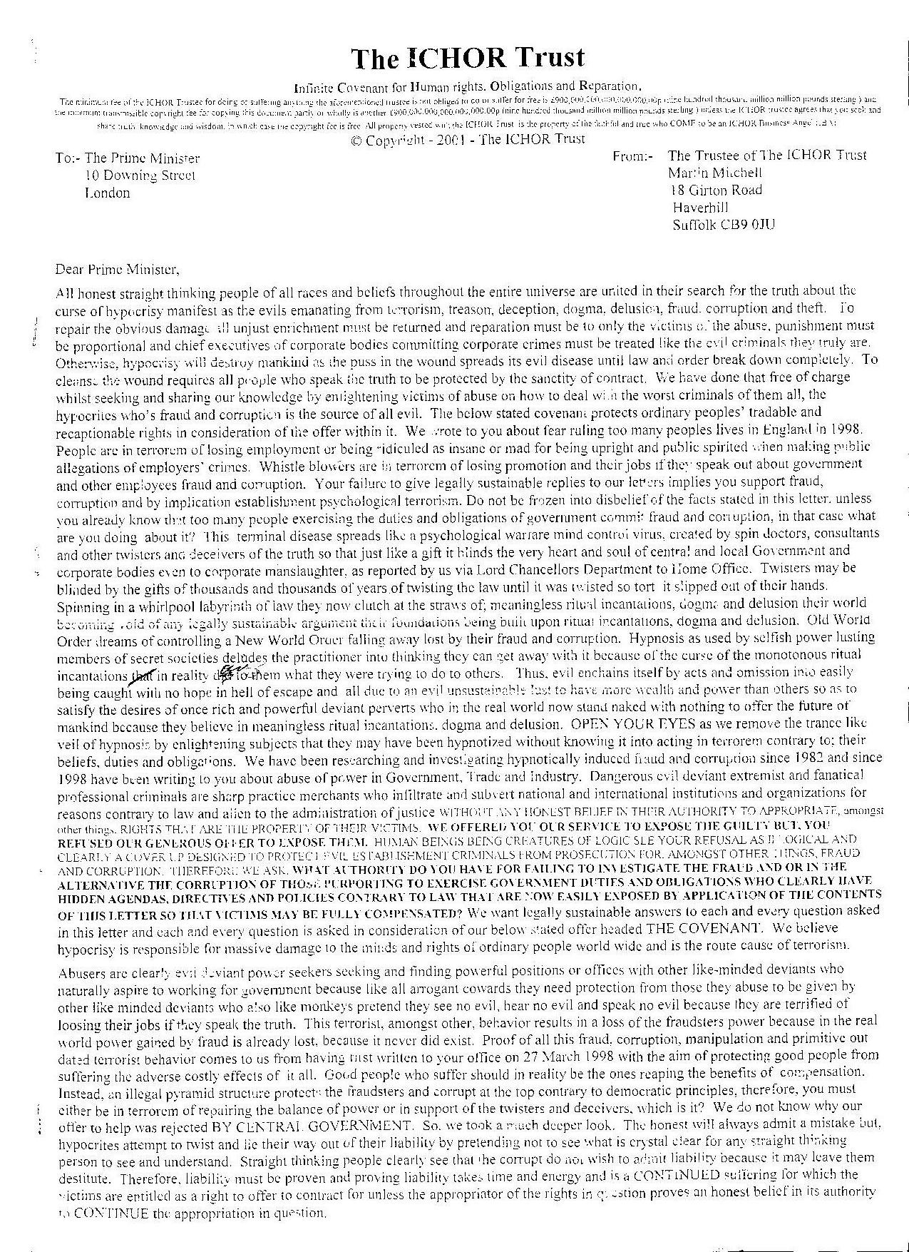
Next

To the Chief Executive Cambridge City Council
The ICHOR Trust
Infinite Covenant for Human rights, Obligations and Reparation.
The minimum fee of The ICHOR Trustee and each and every individual beneficiary for doing or suffering anything one is not obliged to do or suffer at his own expense is £900,000,000,000,000,000.00p (nine hundred thousand million million pounds sterling ) and the minimum transmissible copyright fee for copying this document partly or wholly is another £900,000,000,000,000,000.00p (nine hundred thousand million million pounds sterling ) unless The ICHOR Trustee agrees that you seek and share truth, knowledge and wisdom, in which case the copyright fee is free. All property vested with The ICHOR Trust shall be equally shared amongst all the faithful and true who COME to be an ICHOR Business Angel (IBA) see http://myweb.tiscali.co.uk/ichor under the heading, "WHY NOT BECOME AN ICHOR BUSINESS ANGEL (IBA)"
© Copyright - 2003 - The ICHOR Trust.
Open letter ichortrust.co.uk
To:- Chief Executive Cambridge City Council,
Guild Hall,
Cambridge CB2 3QJ.
From: The Trustee of the ICHOR Trust
Martin Mitchell
18 Girton Road
Haverhill Suffolk CB9 0JU
DATED 5 July 2005
REQUEST FOR AUTHORITIES PURSUANT TO; METROPOLITAN ASYLUM DISTRICT V HILL (1881) 6App Cas. 193 AND ALLEN V GULF OIL REFINING LTD. (1981) AND BLADES V HIGGS (1881) 10 CBNS 713 AND CURRIE V MISA (1875) L.R.10 Exch. 153 AND THE THEFT ACT 1968 S2b AND TERRORIST LEGISLATION AND THE PREVENTION OF BULLYING BY ABUSE OF POWER AND PREVENTION OF THEFT BY DECEPTION OF AUTHORITY AND ALL IN CONSIDERATION OF THE ICHOR TRUST COVENANT.
Dear Sir/madam,
Thank you for your letters dated 29 June 2005 not posted until 4 July 2005 your reference PN/KR and your letter dated 01 July 2005. Your authority is quite clearly permissive see your own letter paragraph 51.- (2) (b). Neither of your letters show me sufficient authority to take away my right to charge fees for suffering the pollution of my environment with street clutter including Parking Meters. Either you are in terrorem of the truth because you have been hypnotized by dogma into believing the Satanic ritual incantations of a criminal ruling class mentality acting for selfish reason alien to the administration of justice ( Alien Devils) or you are Alien Devils my rights being my property and my possessions. Your pathetic statement, “We will not be continuing this correspondence”. Is like a spoilt child saying,” I’m not talking to you any more”, when it knows it has lost the argument. My right to have you show me the authority you rely on to have an honest belief in your authority to appropriate my property is tradable according to contract law and I may offer to charge whatever I wish because no one can be forced to accept an offer they can easily avoid accepting by simply stating the truth.

THE LAW OF CONTRACT.
Rights are clearly property and possessions. Under English Common Law I may do as I please and that means I may trade my rights for as much as my imagination sees fit so long as I exercise a duty of care. I exercise my duty of care by application of the ICHOR TRUST COVENANT. Pursuant to Curry v Misa (1875)”…some right .. “being tradable property, Metropolitan Asylum District v. Hill (1881) 6 App. Cas. 193;42 Digest 7051222 Per Lord Blackburn “An Act is not in the absence of clear language to be construed as taking away property without compensation, and on those who seek to establish that the legislature intended to take away the private rights of individuals lies the burden of shewing that such intention appears by express words or necessary implication.” When rights are protected by the sanctity of contract the necessary implication is that it takes IMPERATIVE WORDS OF EXPRESS MEANING BEYOND ANY DOUBT WHATSOEVER IN PRIMARY LEGISLATION to take away the rights in question. Metropolitan Asylum District v Hill (1881) 6 App. Cas. 193;42 Digest 7051222 also states, “Where the terms of a statute are not imperative, but permissive, the fair inference is that the legislature intended the discretion as to the use of the general powers thereby conferred, should be exercised in strict conformity with private rights.” My view is further supported by Carlil v. Carbolic Smoke Ball Co, Ltd., (1893) and Allen v. Gulf Oil Refining Ltd. (1981). Further, taking into consideration Blade v Higgs (1881) 10CBNS 713, the Theft Act 1968 s2b …rights being…..intangible property and an attempt to defeat the ICHOR TRUST being an attempt to defeat a trust according to the Theft Act 1968 and the COVENANT as stated below invoking the sanctity of contract. Maintaining the sanctity of contract is the supreme public interest and supreme public policy consideration because all global trade depends on maintaining the sanctity of contract and not bringing the sanctity of contract into question.
There is no need for me to waste time, money and energy by going to Court to obtain reparation as I clearly have the right to exercise recaption and do as I please with property that becomes the property of the ICHOR TRUST due to your performance of accepting the overleaf offer by failing to show me authority IN IMPERATIVE WORDS OF EXPRESS MEANING BEYOND ANY DOUBT WHATSOEVER IN A PRIMARY ACT OF PARLIAMENT making it clear that I must suffer the environmental pollution of your parking meters, and other street clutter, AT MY OWN EXPENSE. Merely permissive words stating you may do one thing do not take away my right to do another. You have not shown me section 45 of the Act as numbered 51(1) in your letter to me dated 29 June 2005. In your last paragraph of the same letter you rely on The City Of Cambridge (permitted Parking And Special Parking Area)(Waiting Restrictions And Street Parking Places)(Consolidation ) Order 2004. Unfortunately, Orders, Rules , Regulations and Statutory Instruments, amongst other things, do not take away private rights only Primary legislation in the form of an Act of Parliament has authority to take away private rights when the Act states exactly what must be suffered and by whom AT THEIR OWN EXPENSE see the Copyright Act 1920.
Where are the authorities you must rely on to pollute my environment at my own expense? It is clear your employees are obtaining unjust enrichment from unlawful sources of income based on a corruption of authority and breach of ordinary people’s Common Law tradable rights because you fail to show IMPERATIVE WORDS OF EXPRESS MEANING upon which you must rely to pollute the environment with your street clutter at any affected persons own expense. You may also be considered an example of a source of terrorism and bullying.

THE ICHOR TRUST COVENANT.
A NON-NEGOTIABLE UNILATERAL {( ACCEPT OR GO WITHOUT) TAKE IT OR LEAVE IT} EASILY AVOIDED STANDARD FORM OFFER OF TERMS AND CONDITIONS OF BUSINESS.
For a printable copy in microsoft office format click here

Open Letter to the P.M.
The ICHOR Trust
Infinite Covenant for Human rights, Obligations and Reparation.
The minimum fee of The ICHOR Trustee and each and every individual beneficiary for doing or suffering anything one is not obliged to do or suffer at his own expense is £900,000,000,000,000,000.00p (nine hundred thousand million million pounds sterling ) and the minimum transmissible copyright fee for copying this document partly or wholly is another £900,000,000,000,000,000.00p (nine hundred thousand million million pounds sterling ) unless The ICHOR Trustee agrees that you seek and share truth, knowledge and wisdom, in which case the copyright fee is free. All property vested with The ICHOR Trust shall be equally shared amongst all the faithful and true who COME to be an ICHOR Business Angel (IBA) see http://myweb.tiscali.co.uk/ichor under the heading, "WHY NOT BECOME AN ICHOR BUSINESS ANGEL (IBA)"
© Copyright - 2003 - The ICHOR Trust.
Open letter www.ichortrust.co.uk
To:- The Office of the Prime Minister and First Lord of the Treasury,
10 Downing Street,
London SW1A 2AA.
From: The Trustee of the ICHOR Trust Martin Mitchell
18 Girton Road
Haverhill,
Suffolk
Copied to: The Queen and Defender of the Common Law, CB9 0JU
DATED 14 July 2005
REQUEST FOR AUTHORITIES PURSUANT TO; METROPOLITAN ASYLUM DISTRICT V. HILL (1881) 6App Cas. 193, CURRIE V. MISA (1875) L.R.10 Exch. 153, ALLEN V. GULF OIL REFINING LTD. (1981), THE THEFT ACT 1968 S2b, CARLILL V. CARBOLICK SMOKE BALL CO. (1893), BLADES V. HIGGS (1861) 10C.B., PARKER V. SOUTH EASTERN RAILWAY (1877), TERRORIST LEGISLATION AND A DUTY OF CARE TO PREVENT BULLYING BY ABUSE OF POWER.
Dear Prime Minister and First Lord of the Treasury,
People acting for reasons alien to the administration of justice are aliens employed by bodies both natural and corporate. Aliens within those bodies have hidden agendas, directives and policies contrary to and in contempt of the supreme public policy and supreme public interest consideration. That means aliens ignore the sanctity of contract when people with an honourable vocation expose an alien breach of Law. The quantum merit power of aiming to do good and right even though one may not know what is good and right leads to knowledge and wisdom and deception enchains the deceiver who with bent mind cannot speak without creating mental duplicity loops with forked tongue. Saying one thing and doing another pollutes the speakers mind until it becomes psychotic and schizophrenic. We recognise in others that which lies within ourselves. It is easy to target and catch out those who act for reasons alien to the administration of justice because whilst they appear to be wealthy they have in reality either knowingly or unknowingly appropriated property belonging to others such as their right to breath clean air and their right not to have their environment polluted with clutter. Aliens obfuscate and prevaricate instead of admitting the truth because the truth is socially and financially embarrassing. Who would wish to be seen associating with these social and financial alien outcasts? Body’s natural and corporate acting for reasons alien to the administration of justice find it impossible to provide legally sustainable authorities in reply to our letters and that failure ruins their financial viability whilst exposing them as acting for reasons alien to the administration of justice. Alien devils would rather destroy mankind with their capitalistic global warming and other pollution of our environment than admit they owe damages in reparation for their pollution because the damages owed will wipe out their profits and their capital. The laws of man and God enchain those who rely on authority that in reality does not exist because an Act of Parliament giving one body permission to do one thing does not take away an individuals right to offer to contract for suffering that same thing unless the Act states in express words of implicit meaning which when given a strict and literal reading create a mental picture of exactly what people must suffer at their own expense. We have previously written letters to the Prime Minister’s office but, it has failed to give us legally sustainable replies. The DTI admitted in 1998 our letter raises issues across a number of government policy areas but, what have they done about it? Even though we asked the PM’s Office 21 questions and were told it was the duty of the Home Office to reply we only received acknowledgement from Home Office. Aliens without authority failing to admit the truth must be corrupt and must pay for all damage out of their own pockets. Therefore, we have decided to put our letters in the public domain by publishing them including this one on the world wide web so that the whole world has the opportunity to see how good people’s rights that are their God given property are damaged by the terrorist mentality of selfish dogmatic dogs that are without authority they must in law rely on and obviously be able to produce within 40 days. But, dogs bark dogmatic meaningless satanic ritual incantations designed to hypnotize and mislead people into complying with what must be an illegal hidden agenda, directive or policy contrary to the laws of man and God. The sign of the serpent is, amongst other things, clearly visible in the behaviour of dogs who have clearly lost their heads, because they can no longer think straight being unable to produce authority sufficient to take away a tradable right. Dogs barking satanic ritual incantations prevaricate and obfuscate with the forked tongue of the dying serpent Pythia in an attempt to hide their truly selfish aims and objectives of attempting to retain unjust enrichment gained by stealing and polluting the natural environment of ordinary people with their by-products of environmental and global warming pollution that no one is obliged in any Act of Parliament to suffer at their own expense. Combining quantum physics logic to exposing hidden agendas, directives and policies of dogs attempting to retain the balance of power in favour of a criminal ruling class capitalist mentality contrary to; democratic laws on slavery, theft, Human rights and contract, led us to the deepest deep in which we found easy ways to expose aliens damaging property of the exploited contrary to law. No one can legally sustain an objection to our overleaf offer because only the corrupt are forced to accept the cost of it and they are those dogs that fail to produce the necessary level of authority. We have power to access our genetic make up, scientists refer to as background information on the creation of the universe, simply by thinking and aiming to do good and right. Aliens descending into their void of authority fearful of the truth discover they are locked out of mental evolution and run to their caves, stress of being discovered causing almost instant mental devolution by physical damage via strokes and heart failure due to anxiety induced sleeplessness and prolonged adrenalin turning off their light as we walk over them.
Each and every one of the above and below questions is put to you in consideration of the overleaf offer on an individual and separate basis:-
1) On what legally enforceable authority does government rely to take away any individuals tradable rights not yet taken away by Act of Parliament as having to be suffered at their own expense? See the Copyright Act 1920 for the AT HIS OWN EXPENSE authority.
2) On what legally enforceable authority does government rely to authorise Law Society members to ignore the overleaf offer?
3) On what authority does government rely for taking away an individuals right to contract in consideration of the overleaf offer for continuing to suffer the environmental pollution of industrial by-products, signs, notices, cameras, traffic lights and other street clutter and other environmental pollution when the individual offers to contract in consideration of the overleaf with the body causing the continuing pollution?
THE ICHOR TRUST COVENANT.
A NON-NEGOTIABLE UNILATERAL {( ACCEPT OR GO WITHOUT) TAKE IT OR LEAVE IT} EASILY AVOIDED STANDARD FORM OFFER OF TERMS AND CONDITIONS OF BUSINESS
If you would like to print this click here to download it in microsoft office format

Open Letter to the Queen
The ICHOR Trust
Infinite Covenant for Human rights, Obligations and Reparation.
The minimum fee of The ICHOR Trustee and each and every individual beneficiary for doing or suffering anything one is not obliged to do or suffer at his own expense is £900,000,000,000,000,000.00p (nine hundred thousand million million pounds sterling ) and the minimum transmissible copyright fee for copying this document partly or wholly is another £900,000,000,000,000,000.00p (nine hundred thousand million million pounds sterling ) unless The ICHOR Trustee agrees that you seek and share truth, knowledge and wisdom, in which case the copyright fee is free. All property vested with The ICHOR Trust shall be equally shared amongst all the faithful and true who COME to be an ICHOR Business Angel (IBA) see http://myweb.tiscali.co.uk/ichor under the heading, "WHY NOT BECOME AN ICHOR BUSINESS ANGEL (IBA)"
© Copyright - 2003 - The ICHOR Trust.
Open letter www.ichortrust.co.uk
To:- The Queen and Defender of the Common Law,
Buckingham Palace,
London.
From: The Trustee of the ICHOR Trust Martin Mitchell,
18 Girton Road,
Haverhill,
Suffolk.
Copied to: The Office of the Prime Minister and First Lord of the Treasury. CB9 0JU
DATED 14 July 2005
REQUEST FOR AUTHORITIES PURSUANT TO; METROPOLITAN ASYLUM DISTRICT V. HILL (1881) 6App Cas. 193, CURRIE V. MISA (1875) L.R.10 Exch. 153, ALLEN V. GULF OIL REFINING LTD. (1981), THE THEFT ACT 1968 S2b, CARLILL V. CARBOLICK SMOKE BALL CO. (1893), BLADES V. HIGGS (1861) 10C.B., PARKER V. SOUTH EASTERN RAILWAY (1877), TERRORIST LEGISLATION AND A DUTY OF CARE TO PREVENT BULLYING BY ABUSE OF POWER.
Dear Queen and Defender of the Common Law,
People acting for reasons alien to the administration of justice are aliens employed by bodies both natural and corporate. Aliens within those bodies have hidden agendas, directives and policies contrary to and in contempt of the supreme public policy and supreme public interest consideration. That means aliens ignore the sanctity of contract when people with an honourable vocation expose an alien breach of Law. The quantum merit power of aiming to do good and right even though one may not know what is good and right leads to knowledge and wisdom and deception enchains the deceiver who with bent mind cannot speak without creating mental duplicity loops with forked tongue. Saying one thing and doing another pollutes the speakers mind until it becomes psychotic and schizophrenic. We recognise in others that which lies within ourselves. It is easy to target and catch out those who act for reasons alien to the administration of justice because whilst they appear to be wealthy they have in reality either knowingly or unknowingly appropriated property belonging to others such as their right to breath clean air and their right not to have their environment polluted with clutter. Aliens obfuscate and prevaricate instead of admitting the truth because the truth is socially and financially embarrassing. Who would wish to be seen associating with these social and financial alien outcasts? Body’s natural and corporate acting for reasons alien to the administration of justice find it impossible to provide legally sustainable authorities in reply to our letters and that failure ruins their financial viability whilst exposing them as acting for reasons alien to the administration of justice. Alien devils would rather destroy mankind with their capitalistic global warming and other pollution of our environment than admit they owe damages in reparation for their pollution because the damages owed will wipe out their profits and their capital. The laws of man and God enchain those who rely on authority that in reality does not exist because an Act of Parliament giving one body permission to do one thing does not take away an individuals right to offer to contract for suffering that same thing unless the Act states in express words of implicit meaning which when given a strict and literal reading create a mental picture of exactly what people must suffer at their own expense. We have previously written letters to the Prime Minister’s office but, it has failed to give us legally sustainable replies. The DTI admitted in 1998 our letter raises issues across a number of government policy areas but, what have they done about it? Even though we asked the PM’s Office 21 questions and were told it was the duty of the Home Office to reply we only received acknowledgement from Home Office. Aliens without authority failing to admit the truth must be corrupt and must pay for all damage out of their own pockets. Therefore, we have decided to put our letters in the public domain by publishing them including this one on the world wide web so that the whole world has the opportunity to see how good people’s rights that are their God given property are damaged by the terrorist mentality of selfish dogmatic dogs that are without authority they must in law rely on and obviously be able to produce within 40 days. But, dogs bark dogmatic meaningless satanic ritual incantations designed to hypnotize and mislead people into complying with what must be an illegal hidden agenda, directive or policy contrary to the laws of man and God. The sign of the serpent is, amongst other things, clearly visible in the behaviour of dogs who have clearly lost their heads, because they can no longer think straight being unable to produce authority sufficient to take away a tradable right. Dogs barking satanic ritual incantations prevaricate and obfuscate with the forked tongue of the dying serpent Pythia in an attempt to hide their truly selfish aims and objectives of attempting to retain unjust enrichment gained by stealing and polluting the natural environment of ordinary people with their by-products of environmental and global warming pollution that no one is obliged in any Act of Parliament to suffer at their own expense. Combining quantum physics logic to exposing hidden agendas, directives and policies of dogs attempting to retain the balance of power in favour of a criminal ruling class capitalist mentality contrary to; democratic laws on slavery, theft, Human rights and contract, led us to the deepest deep in which we found easy ways to expose aliens damaging property of the exploited contrary to law. No one can legally sustain an objection to our overleaf offer because only the corrupt are forced to accept the cost of it and they are those dogs that fail to produce the necessary level of authority. We have power to access our genetic make up, scientists refer to as background information on the creation of the universe, simply by thinking and aiming to do good and right. Aliens descending into their void of authority fearful of the truth discover they are locked out of mental evolution and run to their caves, stress of being discovered causing almost instant mental devolution by physical damage via strokes and heart failure due to anxiety induced sleeplessness and prolonged adrenalin turning off their light as we walk over them.
Each and every one of the above and below questions is put to you in consideration of the overleaf offer on an individual and separate basis:-
1) On what legally enforceable authority does government rely to take away any individuals tradable rights not yet taken away by Act of Parliament as having to be suffered at their own expense? See the Copyright Act 1920 for the AT HIS OWN EXPENSE authority.
2) On what legally enforceable authority does government rely to authorise Law Society members to ignore the overleaf offer?
3) On what authority does government rely for taking away an individuals right to contract in consideration of the overleaf offer for continuing to suffer the environmental pollution of industrial by-products, signs, notices, cameras, traffic lights and other street clutter and other environmental pollution when the individual offers to contract in consideration of the overleaf with the body causing the continuing pollution?
THE ICHOR TRUST COVENANT.
A NON-NEGOTIABLE UNILATERAL {( ACCEPT OR GO WITHOUT) TAKE IT OR LEAVE IT} EASILY AVOIDED STANDARD FORM OFFER OF TERMS AND CONDITIONS OF BUSINESS.

Letters From
- Downing Street 4th June 2001
- Home Office 14th June 2001
- House of Commons 17th July 2001
- Lord Chancellors Department 13th November 2000
- Lord Chancellors Department 2nd August 2001
- Lord Chancellors Department 8th August 2001
- Terms of business conformation of recipe
- The Patent Office 13th May 1998
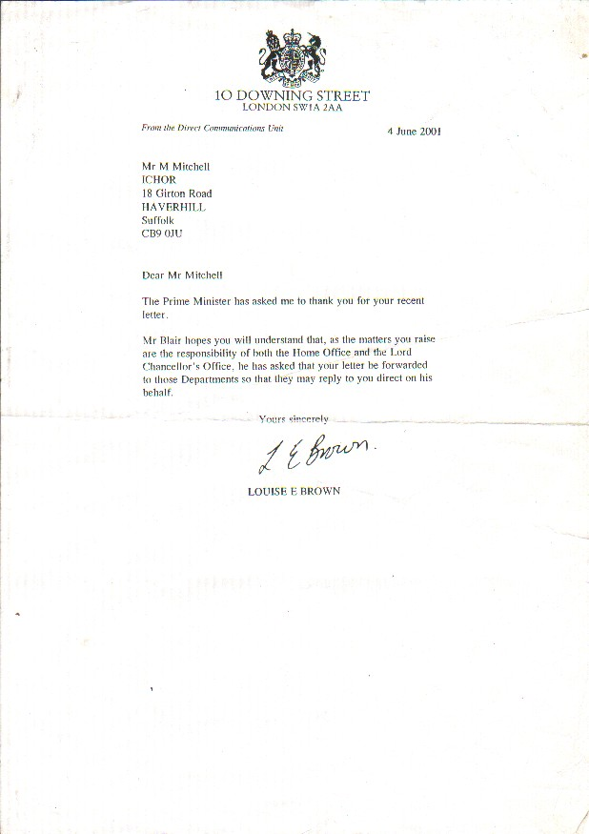
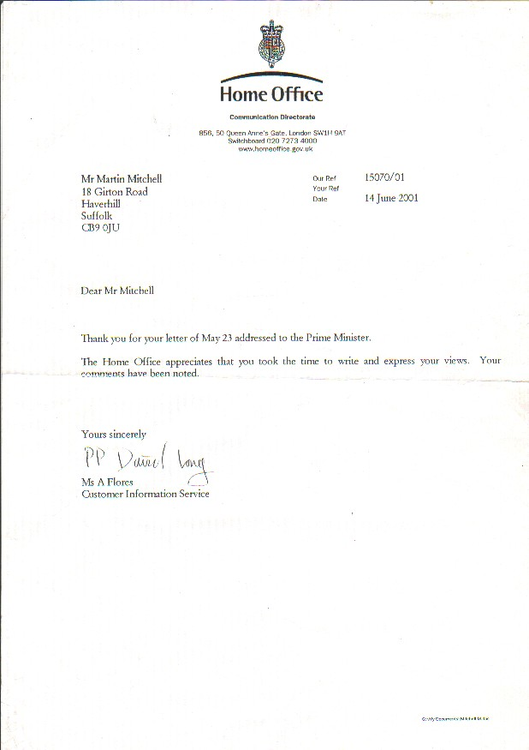
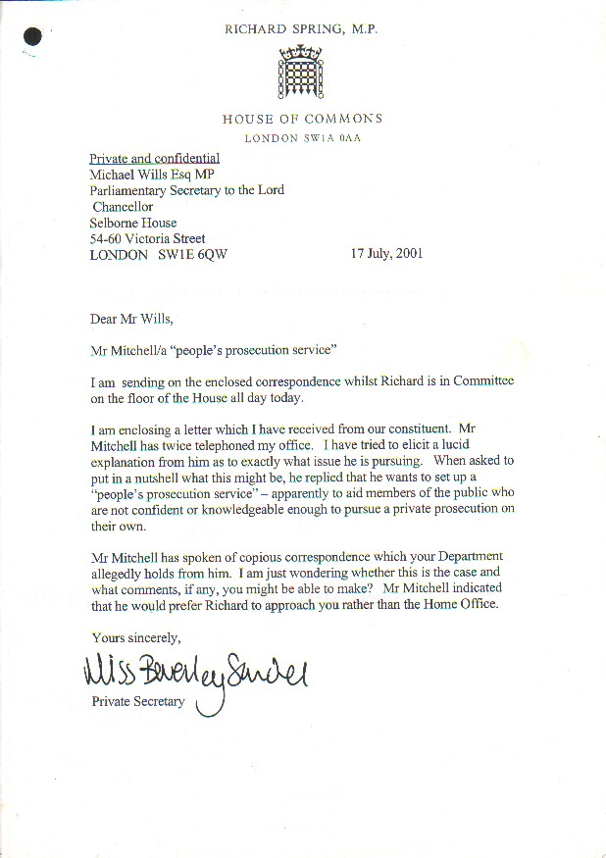
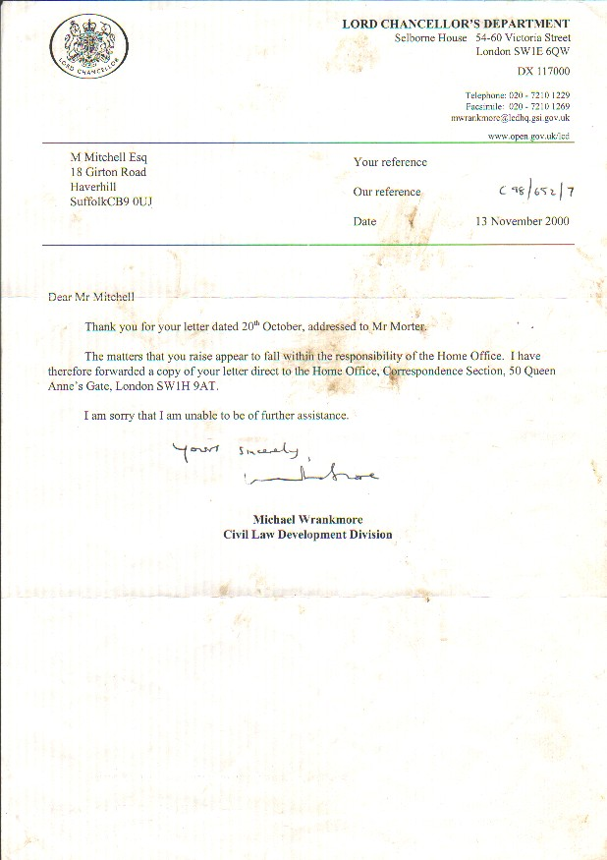
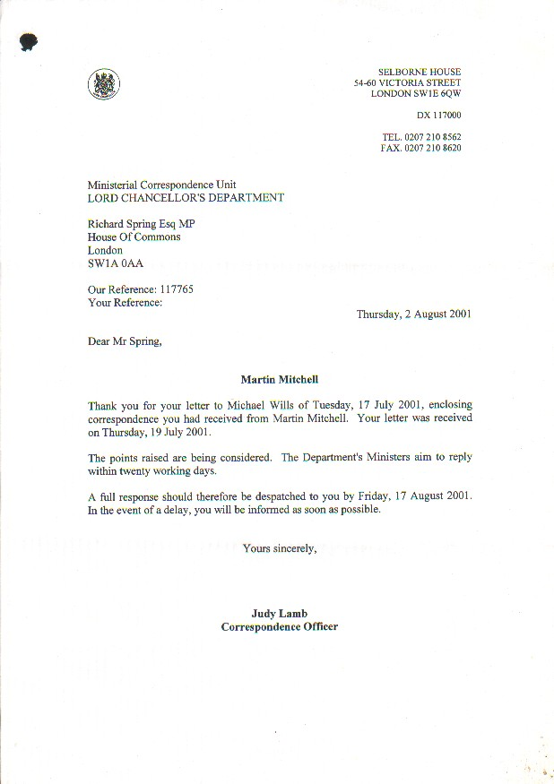
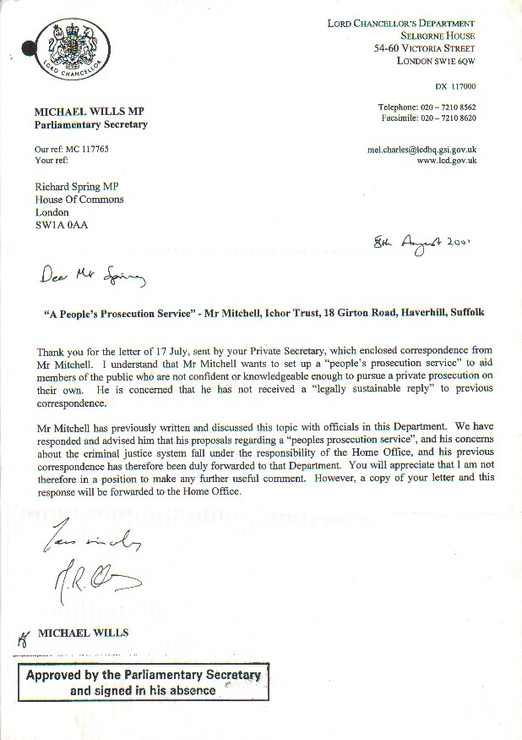
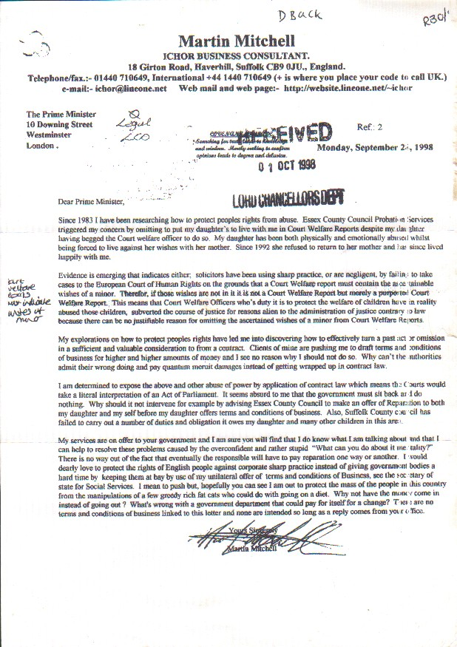
z\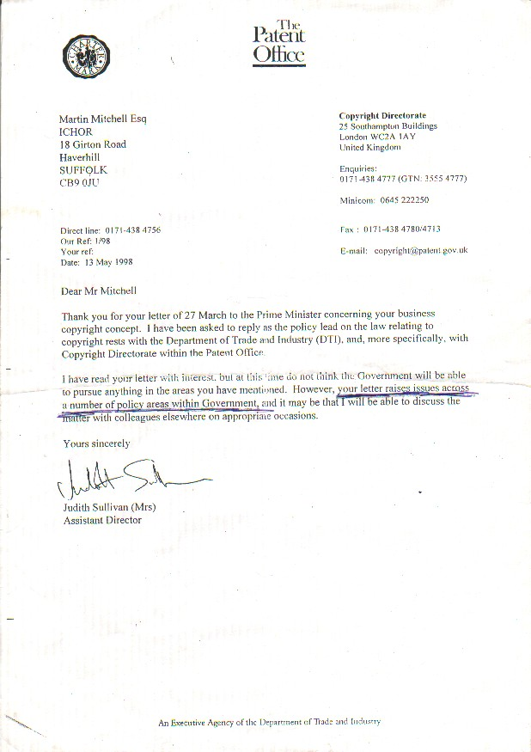

Contacts
Martin Mitchell
Martin is the one to contact about any of the content of this site as he is the one who did all the studding and letter Writing, so any questions or comments please direct them to him. Thanks
trustee@ichortrust.co.uk
Web Master Stewart Crombie MCITP, Certified Web Designer
Please inform me of any broken links spelling mistakes or suggestions about the site thanks.
0870 803 1720
Email here
trustee@ichortrust.co.uk < trustee@ichortrust.co.uk>

