 | Court Funds Office  Children’s Division  22 Kingsway  London  WC2B 6LE  DX 149780 KINGSWAY 5  Tel: 020 7947  Fax: 020 7947 7497  Minicom: 020 7947 7911  childrens@hmcourts-service.gsi.gov
´BEN_NAMª
´ADD1ª
´ADD2ª
´ADD3ª

´BEN_NAMª  ´ADD1ª  ´ADD2ª  ´ADD3ª | Date: 28 July 2026
Dear Sir/Madam | Date: 28 July 2026
A/c Holder:
A/c Number:

You will shortly be reaching your 18th birthday when you will become entitled to the fund, which is currently being held in Court on your behalf.

On or after your 18th birthday, the enclosed Form 203 Payment on Majority should be completed and returned to this office together with a photocopy of your birth certificate to enable payment to be made. You will need to sign the form in the presence of a witness, who must know you and be a professional person or a person of standing in the community. The witness must not be a relative of yours.

Please do not send your original birth certificate in the post. Instead, take the original certificate and a photocopy of it with you when you meet with your witness. Please ask the witness to compare the original with the photocopy and to endorse the photocopy with the words ‘I declare that this a true copy of the birth certificate of….’. The witness should then put their signature and the date on the photocopy, which should be attached to the Payment on Majority Form and returned to this office at the address above.

If payment is to be made to a bank outside of the UK you will need to find out from your bank details of their receiving bank in the UK to which payment will be made. You will need to provide full details of BOTH bank accounts on the Form 203 or provide these details to the court.

Please note that this form must not be signed or witnessed before your 18th birthday. Funds are issued as a first class cheque by post. Please allow fourteen days from the date of posting for funds to be paid from the balance on the special account into your bank or building society account.

Yours Sincerely,

Children’s Division
Court Funds Office

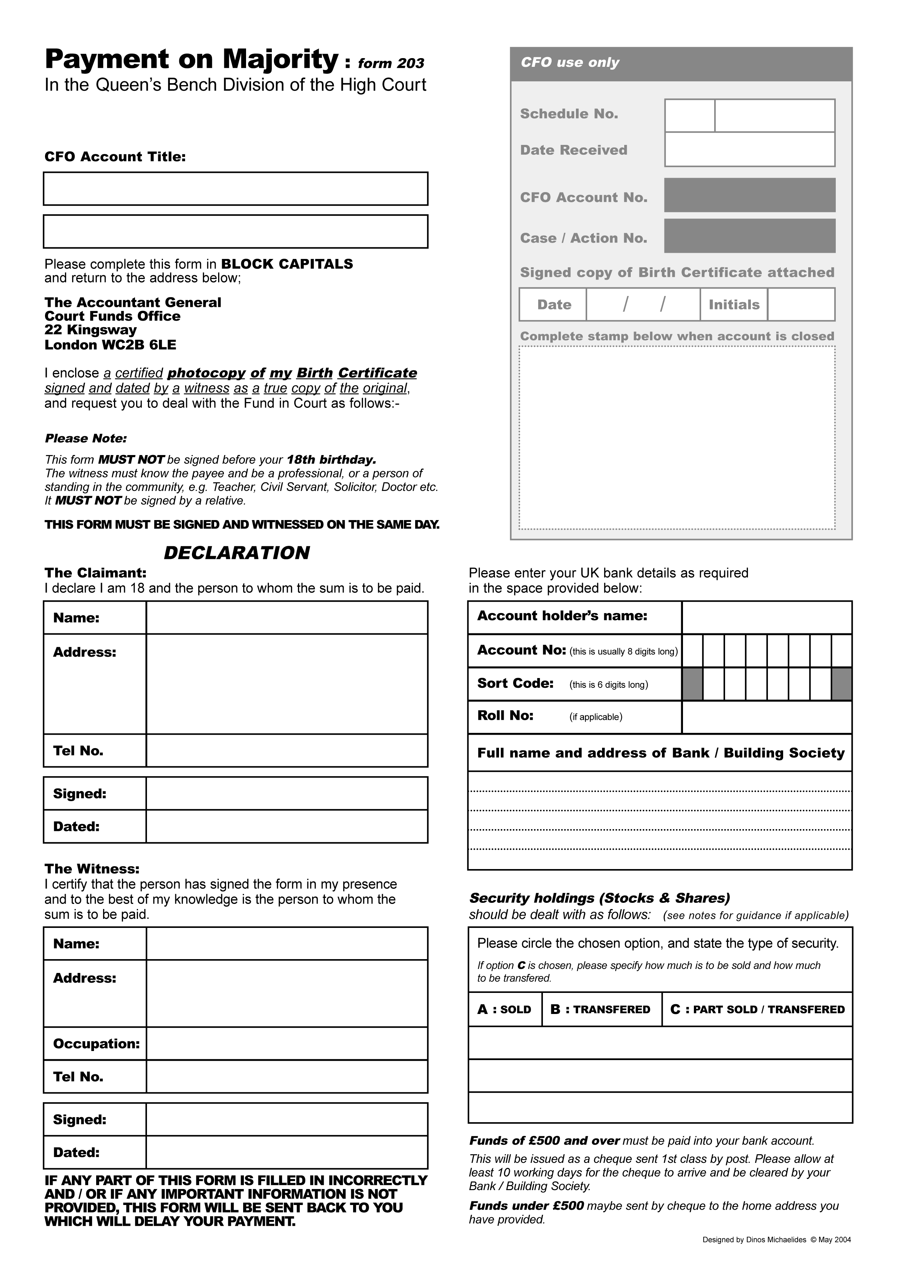

´ACC_TITLEª
´ACC_NOª

A/C ´BEN_NAMª
´CASE_NOª

INFORMATION SHEET – PLEASE READ CAREFULLY

GUIDANCE NOTES FOR CHILDREN ON REACHING THE AGE OF 18 YEARS

SPECIAL AND BASIC ACCOUNTS

This money must be withdrawn and paid to you. Once you reach 18 all interest on your Fund is credited to the basic account, which accrues interest at a lower rate.

SECURITY HOLDINGS

There are three options open to you in relation to each security held on your behalf: -

- They can be sold and the proceeds of sale paid to you.
- They can be transferred into your name, in which case dividends will be paid to you at regular intervals each year
until you sell the holding.
- Part of them can be sold and part transferred into your name.

To find out the current value of your security holding, current prices can be found in the “Financial Times”,
Common Investment Fund Units are listed under F.T. subheading “Managed Funds Services”, “DCA Common Investment Funds”.

Please bear in mind that the actual value is subject to market fluctuations and might rise or fall accordingly.
Some of the “Other security holdings”, if sold, may also be subject to broker’s commission, V.A.T. etc. In addition further interest may be due to you by the time payment is made. It is suggested that if you are in doubt as to which of the 3 options to choose, you should contact or consult either your Bank Manager or other financial adviser.

Please ensure that your instructions are shown clearly on the CFO Form 203 or are made perfectly clear to the Court if seeking an Order for payment out of the fund.

PAYMENTS

Any funds of £500 or over must be remitted directly to your Bank Account for reason of security. Details of your account must be supplied either to the Court with your application for payment out or to the Court Funds Office when returning CFO Form 203. Please note that we cannot accept 3rd party account details (e.g. friend/relative), the details provided must be in your name only.

Please note, that if you have received legal aid your payment may be delayed by a further ten working days while we confirm any outstanding charges. If you are still in contact with your solicitors we would advise that you enclose a signed letter from them confirming that there are no re-payments due.

PAYMENTS TO BANKS OUTSIDE THE UK

If payment is to be made to a bank outside of the UK, you will need to find out from your bank, details of their receiving bank in the UK to which payment will be made. You will need to provide full details of BOTH bank accounts on the CFO Form 203 or provide these details to the Court.

WITNESSES (Form 203 only)

Examples of whom we can accept are shown on the next page. Please note, if you do not know any of the mentioned acceptable witnesses you will have to apply to the court where the matter was heard and apply for the monies to be released. We will return the F203 back to you if you have not given an acceptable witness.

- The witness must have known you for at least two years
- The witness must certify, sign and date the copy Birth Certificate with the words, “I certify that this is a true copy of the Birth Certificate of <YOUR NAME>”.

N.B. The witness must sign and date the Form 203 on the same date as you and the date must NOT be before your 18th Birthday

ACCEPTABLE WITNESSES

Accountant | Articled Clerk of a Limited Company
Assurance Agent of Recognised Company | Bank / Building Society Official
Barrister | Broker
Chairman/Director of Limited Company | Chemist
Chiropodist | Christian Science Practitioner
Commissioner of Oaths | Councillor: Local or County
Civil Servant (Permanent) | Doctor / Dentist (Registered)
Engineer (with professional Qualifications) | Fire Service Official
Funeral Director | Insurance agent (full time) of a recognised  Company
Journalist (Professional) | Justice of the Peace
Legal Secretary (Members and fellows of the  Institute of Legal secretaries) | Licensee
Local Government Officer | Manager / Personnel Officer  (of Limited Company)
Member of Parliament | Merchant Navy Officer
Minister of a recognised religion | Nurse (SRN and SEN)
Officer of the Armed Services  (Active or Retired) | Optician
Paramedic (State registered) | Person with Honours (e.g. OBE MBE etc)
Photographer (Professional) | Police Officer
Post Office Official | President / Secretary of a  recognised organisation
Salvation Army Officer | Solicitor
Surveyor | Teacher / Lecturer
Trade Union Officer | Travel Agency (Qualified)
Valuers and Auctioneers (Fellow and  associate members of the incorporated soc.) | Warrant Officers and Chief Petty Officers

